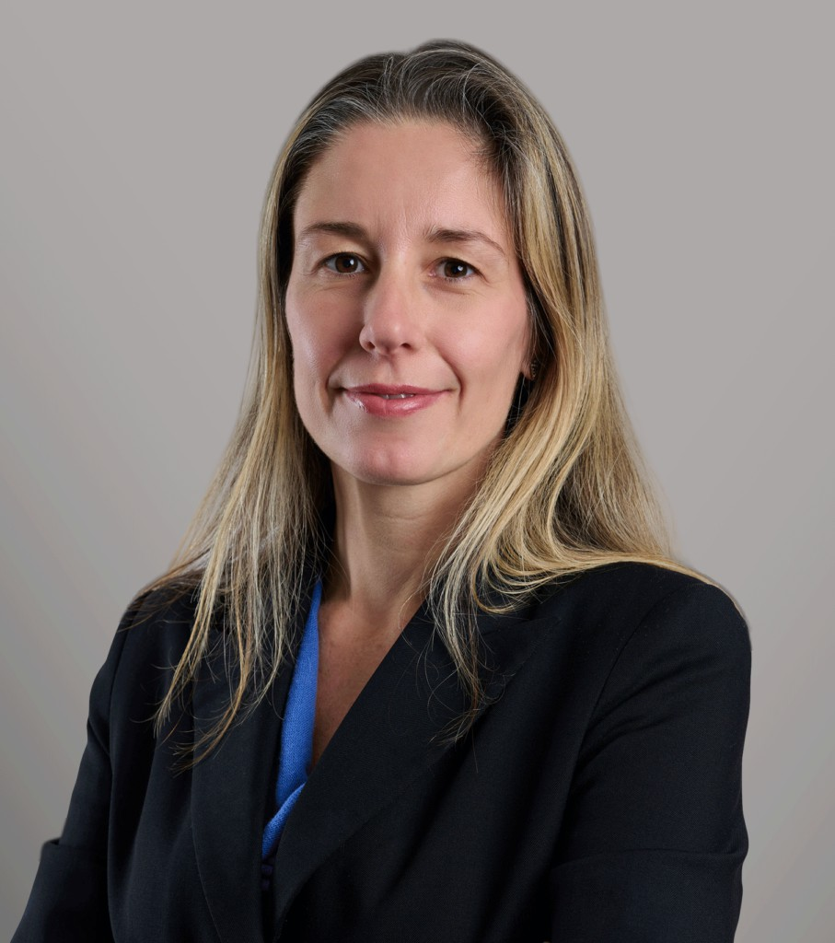

SARAH GOHMANN BIGELOW

Of Counsel

[Business Litigation](https://www.fennemorelaw.com/services/business-litigation/)

[Seattle](https://www.fennemorelaw.com/contact-us/seattle/)

P: 206.749.0500 F: 206.749.0600

[sgohmann@fennemorelaw.com](mailto:sgohmann@fennemorelaw.com)

“

It is never too late to be what you might have been.

George Eliot

**SARAH GOHMANN BIGELOW**

”

Sarah Gohmann Bigelow’s commercial litigation experience, encompassing a variety of cases in both state and federal courts, is marked by her in-depth legal knowledge, strategic thinking, creative problem solving, and robust litigation skills. She has been actively involved in all stages of litigation, dealing with disputes arising from business torts, contracts, fiduciary duties, class

actions, and employment claims.

Sarah honed her legal skills at Bryan Cave in Los Angeles and more recently at the Seattle litigation boutique Savitt Bruce & Willey, which combined with Fennemore to become the firm’s Seattle office. Sarah also served as a law clerk to the Honorable Thomas B. Donovan of the United States Bankruptcy Court for the Central District of California. A UCLA Law School alumni, she served as Symposium Editor for the UCLA Law Review and Co-Chief Articles Editor for the UCLA Women’s Law Journal, reflecting her commitment to legal scholarship and excellence. Her approach in litigation is client-focused and strategic, aimed at achieving favorable outcomes through effective legal strategies and clear communication, planning, and management.

Outside the office, Sarah enjoys volunteering at her daughters’ elementary school and spending time with her friends and family in the Green Lake neighborhood. Sarah is passionate about outdoor adventures and loves spending time in the North Cascades. She has traveled extensively—including teaching English in Japan for a year—and continues to seize every opportunity to do so. She always enjoys getting out for a run.

# EDUCATION

J.D., University of California, Los Angeles School of Law B.A., University of Michigan, with Honors

# AREAS OF PRACTICE

**OTHER EXPERIENCE**

Class Action Business Litigation

Employment & Labor Intellectual Property

# REPRESENTATIVE MATTERS

Defended startup and its founders against claims for misappropriation of trade secrets, usurpation of corporate opportunity and breach of fiduciary duty; obtained ruling entitling clients to indemnification from plaintiffs for attorneys’ fees incurred, partial summary judgment rulings, and then favorable settlement.

Undertook detailed analysis of possible conflicts issues for publicly-owned hospital, and prepared a conflict of interest policy for the board of trustees.

Defended against claims for breach of contract relating to technology services; obtained favorable settlement.

Defended California grower against class actions alleging wage and hour claims; following a successful motion to decertify certain subclasses and briefing on the infeasibility of a resolution of class claims by trial, obtained favorable settlement.

Prosecuted claims on behalf of a bank for fraud, negligent misrepresentation and breach of contract against local fraudster who was subsequently convicted in federal court for his

crimes; obtained temporary restraining order, preliminary injunction, summary judgment and final judgment in favor of the bank.

Defended a municipality against two former and one current employees’ claims under Washington Law Against Discrimination for age, gender, and sexual orientation discrimination, retaliation, and hostile work environment; while client’s motions for summary judgment were pending, case settled on confidential terms.

Served as counsel to a special litigation committee formed to investigate and determine whether to prosecute derivative claims; advised committee throughout investigation,

deliberative, and reporting process.

Defended energy company against breach of contract claims and pursued counterclaims against contractor based on breach of contract and fraud; obtained favorable settlement prior to trial.

Successfully defended client against claims that its venue violated ADA accessibility standards including securing a judgment in favor of the client on all claims after remand from the Ninth Circuit Court of Appeals.

After removing case to the United States District Court, defended multinational technology company against claims of employment discrimination and wrongful termination; obtained favorable settlement for company while its motion for summary judgment was pending.

Defended third-party lender in a property dispute alleging unlawful dissociation, conversion, fraudulent misrepresentation and negligence; obtained favorable settlement for client.

Defended county against claims brought by local landowners when their property was flooded during a storm; obtained favorable settlement for client before trial.

Defended municipality against wrongful termination claims brought by former employees; won rulings by the trial court upholding the client’s attorney-client privilege and work product protections and denial of appellate review; obtained favorable settlement.

# AWARDS AND HONORS

Super Lawyer, 2024

Washington Rising Star, Super Lawyers, 2013-2016

# ARTICLES AND PRESENTATION

Lexis Nexis Practice Guide: Washington Contract Litigation, Contributor (LexisNexis/Matthew Bender 2015)

# ADMISSIONS

Washington

United States Court of Appeals, Ninth Circuit

United States District Court, Western District of Washington United States District Court, Eastern District of Washington United States District Court, Northern District of California United States District Court, Central District of California United States District Court, Southern District of California United States District Court, Eastern District of California