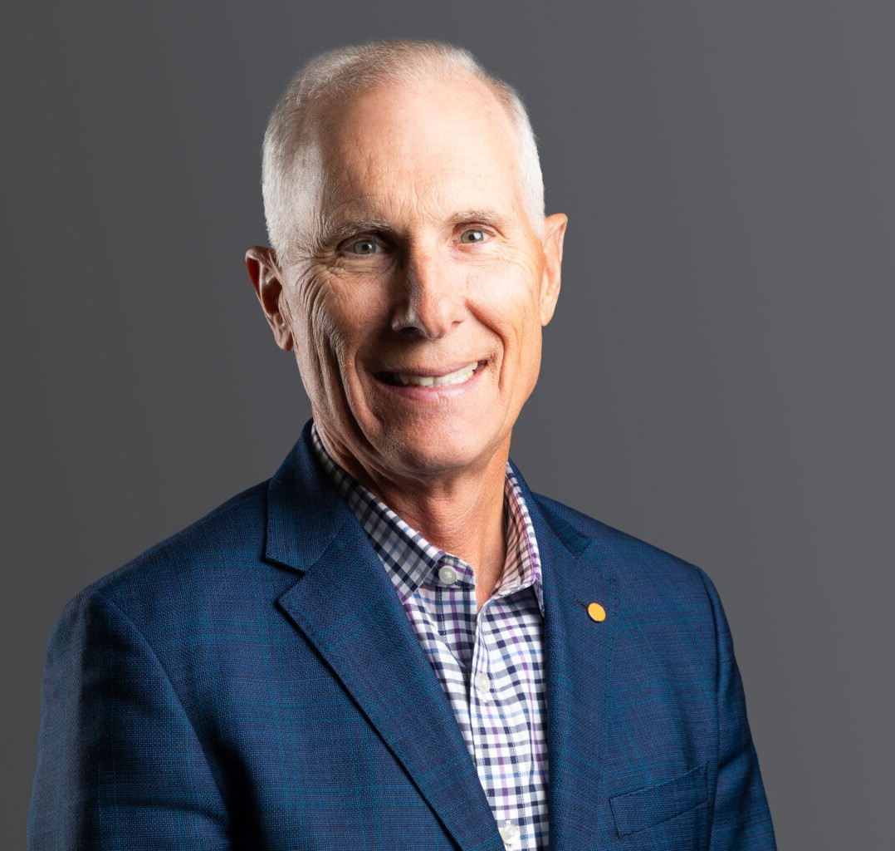

SCOTT P. GREINER

Director

[Trusts & Estates](https://www.fennemorelaw.com/services/trusts-estates/)

[Denver](https://www.fennemorelaw.com/contact-us/denver-2/)

P: 303.813.3823 F: 303.291.3201

[sgreiner@fennemorelaw.com](mailto:sgreiner@fennemorelaw.com)

# SCOTT P. GREINER

As an experienced tax attorney, Scott counsels clients on how to effectively structure their business, oil and gas, and real estate ventures, as well as insulate wealth from transfer taxes.

Scott has both the knowledge and vision to assist business owners, oil and gas executives and their families in accumulating and preserving long-term business and personal wealth. He provides invaluable guidance on selecting tax-advantageous business entities, identifying opportunities to increase after-tax income, structuring deferred and reverse like-kind exchanges, planning business expansions and acquisitions, and transferring wealth generationally in a tax- wise manner.

As part of his comprehensive business counsel, Scott advises clients on methodologies to attract and retain employees through a variety of tax-deferred compensation arrangements: incentive stock options, nonqualified stock options, phantom equity plans, and nonqualified deferred compensation arrangements. To maximize investment, Scott devises business continuity plans for transitioning businesses to key employees or younger family members and also develops innovative exit strategies in cases of sales to third parties. When needed, Scott is a vigorous advocate for his clients in resolving tax disputes before the Internal Revenue Service, the U.S. Tax Court, and the U.S. Court of Federal Claims.

With an eye towards security and stability, Scott assists clients with their estate and business planning needs through creative income, estate, and gift tax strategies. One area of special interest is the establishment of limited family partnerships and devising estate freezing

transactions. He also assists clients with their philanthropic objectives through the formation of private family foundations, as well as charitable lead and charitable remainder trusts.

Scott frequently writes and lectures on a variety of sophisticated tax topics and provides expert witness testimony on tax matters. He has authored extensive course materials for CLE of

Colorado, Inc., National Business Institute, Inc., Rocky Mountain Estate Planning Council, Greater Denver Tax Counsel’s Association, ING-Security Life of Denver, and National Association of Certified Valuation Analysts. He also has written several articles for The Colorado Lawyer, Denver Business Journal, and Denver Real Estate Journal.

# EDUCATION

LL.M., Taxation, University of Denver J.D., Tulane University

B.A., Tulane University

# AREAS OF PRACTICE

**OTHER EXPERIENCE**

Business, Oil and Gas, and Real Estate Income Tax Planning Buy-Sell Agreements

Captive Insurance Companies

Partnership/LLC/S Corp Tax Planning

Private Foundations and Charitable Trust Planning Expert Witness

Trust and Estate Administration Trust and Estate Planning

Trusts & Estates Business Litigation Tax Law

Estate Planning

# AWARDS AND HONORS

5280 Magazine, Denver Five Star Wealth Manager, Taxation, 2009 – 2013 Best Lawyers®, Tax Law, 2022 – 2024; Trusts and Estates, 2023 – 2025

Law Week Colorado, People’s Choice “Barrister’s Best” Tax Lawyer 2019 Martindale-Hubbell Rating, AV® Preeminent™ (highest)

# ARTICLES AND PRESENTATIONS

Moderator, “[Getting Coloradoans Back to Work](https://vimeo.com/422954157),” ccc Webinar, May 2020

Co-Author, “[Proposed Changes to the Federal Tax Law and Their Potential Impact on Existing](https://www.moyewhite.com/news-insights/blog/october-202/proposed-changes-to-the-federal-tax-law-and-their) [Estate Plans](https://www.moyewhite.com/news-insights/blog/october-202/proposed-changes-to-the-federal-tax-law-and-their),” *Firm Blog*, October 18, 2021

Author, “[2017 Tax Reform: What Business Owners Need to Know](https://www.moyewhite.com/getmedia/577ca8d7-ce1d-40b5-a24d-d96f28f87cb2/Tax-Cut-and-Jobs-Act-CBA-Business-Law-Institute-09-12-18-4816-6798-4755-v-1.pdf),” *2018 Business Law Institute*, September 2018

Author, “[Tax Reform Spells Tax Relief For Colorado Businesses](https://www.moyewhite.com/news-insights/blog/january-2018/tax-reform-spells-tax-relief-for-colorado-businesses),” *ColoradoBiz Magazine*, January 2018

Author, “[Important Changes To Consider](https://www.moyewhite.com/news-insights/blog/september-2016/important-changes-to-consider)” September 2016

Author, “[3 Reasons to Use a Charitable Remainder Trust as a Tax-Savings Tool](https://www.moyewhite.com/news-insights/blog/september-2014/3-reasons-to-use-a-charitable-remainder-trust-as-a-tax-savings-tool),” September 2014

Author, “[How to Deduct Marijuana Expenses](https://www.moyewhite.com/news-insights/blog/january-2014/how-to-deduct-marijuana-expenses),” *TheStreet*, January 2014

Author, “[Can You Afford to Wait to Sell Your Business?](https://www.moyewhite.com/news-insights/blog/may-2012/can-you-afford-to-wait-to-sell-your-business),” *Denver Business Journal*, May 2012

Author, “[Legislature Comes to Rescue of Conservation Easement Taxpayers](https://www.moyewhite.com/news-insights/blog/august-2011/legislature-comes-to-rescue-of-conservation-easement-taxpayers),” *Colorado Real Estate Journal*, August 2011

Co-author, “[Navigating LLC Waters](https://www.moyewhite.com/news-insights/blog/october-2008/navigating-llc-waters),” *The Financial Manager*, September/October 2008

Author, “Tips for Transferring Wealth from Generation to Generation,” *Denver Business Journal*, September 2008

Co-Presenter, “[Selling Your Business](https://www.bizjournals.com/denver/feature/table-of-experts/selling-your-business.html),” Denver Business Journal Table of Experts, October 18, 2019

Co-Presenter, “The 2017 Tax Cuts and Jobs Act (TCJA) in 2019: Some Explanations, Examples, and Impact,” Business Law Institute, September 12, 2019

# PROFESSIONAL AND COMMUNITY AFFILIATIONS

Former Executive Council, Tax Section, Trust Section, and Estate Section, Colorado Bar Association

Former President, Greater Denver Tax Counsel’s Association

# ADMISSIONS

Colorado North Dakota