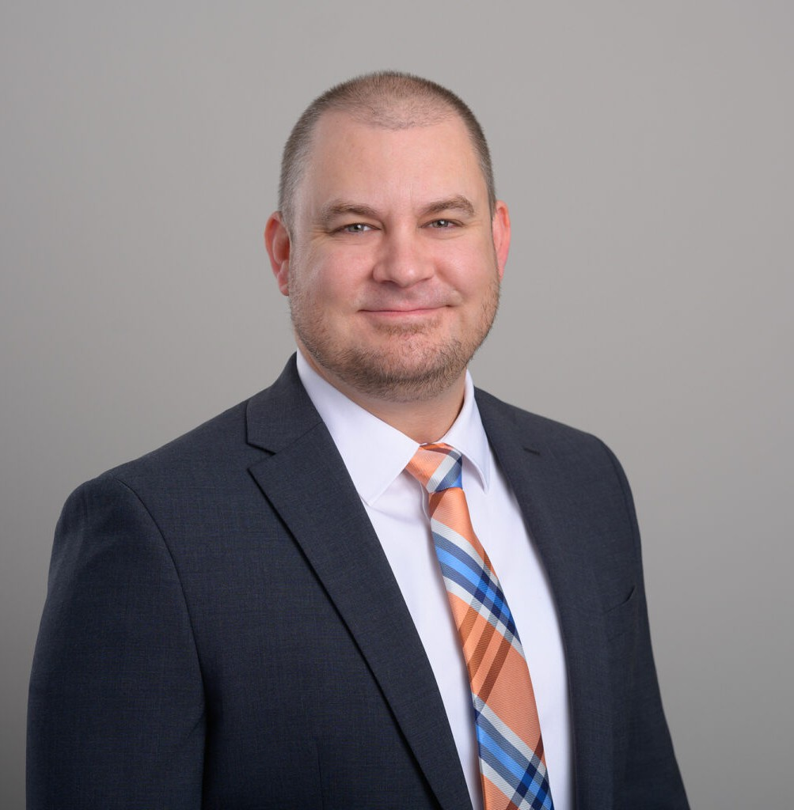

SEAN E. STORY

Associate

[Business Litigation](https://www.fennemorelaw.com/services/business-litigation/)

[Las Vegas](https://www.fennemorelaw.com/contact-us/las-vegas/)

P: 702.692.8010 F: 702.692.8099

[San Diego](https://www.fennemorelaw.com/contact-us/san-diego/)

P: 619.595.3243 F: 619.231.4372

[sstory@fennemorelaw.com](mailto:sstory@fennemorelaw.com)

# SEAN E. STORY

Sean Story, part of the Business Litigation and Construction practice groups, is known for his client-focused approach and for providing results-driven legal counsel. His career is marked by notable achievements and a dedication to addressing clients’ needs effectively.

A graduate with distinction from the University of Arizona James E. Rogers College of Law, Sean was a recipient of the Dorothy H. and Lewis Rosenstiel Scholarship and consistently featured on the Dean’s List. His involvement extended to serving as an Articles Editor for and having his article on cross-border insolvency published by the Arizona Journal of International and Comparative

Law. Sean also participated in and held executive committee positions on various legal student organizations, highlighting his active engagement in the legal community.

Sean’s practice, characterized by strategic problem solving and comprehensive legal analysis, ensures clients receive informed and effective representation in the fields of litigation,

construction, and resolution of internal business and partnership disputes. Sean is also the former owner of SDRC Raceway in San Diego, CA, which provided invaluable experience with being familiar with and attentive to small business client needs. His commitment to legal excellence makes him a valuable member of the Fennemore team.

# EDUCATION

J.D., University of Arizona James E. Rogers College of Law B.S., California State University, Bakersfield

# AREAS OF PRACTICE

Business Litigation Construction Law

# PROFESSIONAL AND COMMUNITY ACTIVITIES

National Institute of Trial Advocacy 3-day Deposition Training Program Top 10 World-Ranked Flair Bartending, 2007-2008

Golf Channel Amateur Championship National Finalist, 2008-2010

# ADMISSIONS

California Nevada