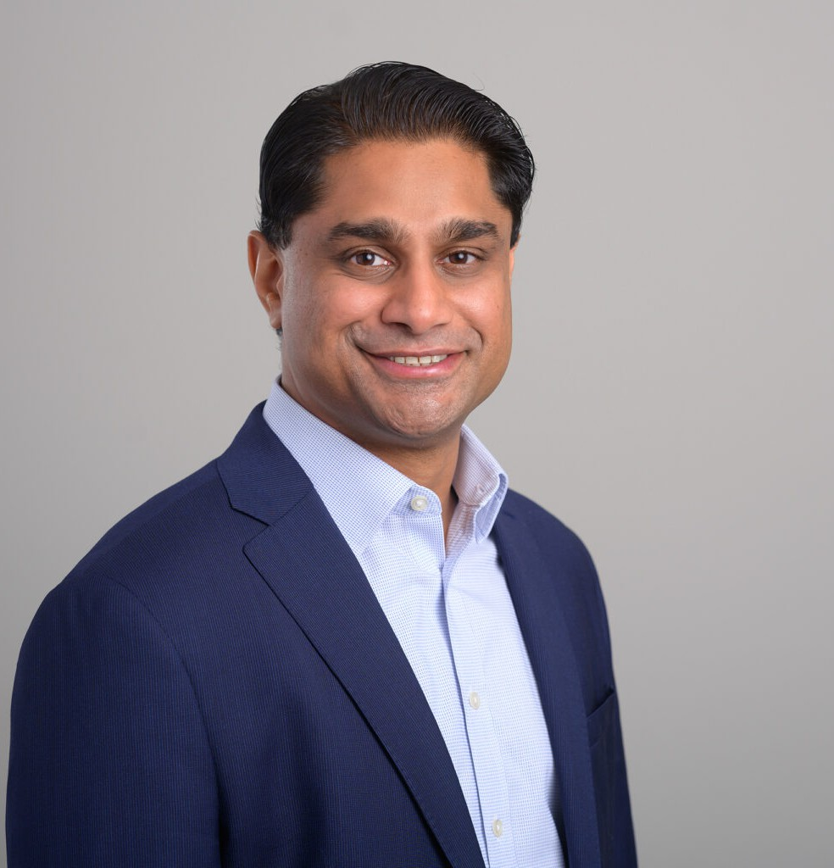

SHAILENDRA (SHAY) KULKARNI

Director

[Business Litigation](https://www.fennemorelaw.com/services/business-litigation/)

[San Diego](https://www.fennemorelaw.com/contact-us/san-diego/)

P: 619.595.3204 F: 619.231.4372

[skulkarni@fennemorelaw.com](mailto:skulkarni@fennemorelaw.com)

# SHAILENDRA (SHAY) KULKARNI

Shailendra “Shay” Kulkarni, a member of the Construction and Litigation practice groups, is a skilled litigator and noted speaker who utilizes his comprehensive construction law expertise to assist contractors, real estate developers, and other business entities in dispute resolution. He focuses on construction and real estate litigation, insurance coverage litigation and analysis, and complex civil litigation, including surety litigation and construction-industry contracts.

Shay is the former Chair of the Construction Law Practice Area Committee of the California Lawyers Association and the former two-time Chairman of the Construction Law Section of the San Diego County Bar Association. He currently also serves as the Chair of Division 5 (General

Contractors) of the ABA Forum on Construction Law, and as a fellow of the Construction Lawyers Society of America. Shay also proudly serves the San Diego community as an Advisory Board Member and Mentoring Program Co-chair for the Crawford Academy of Law program, and as a member of the Build and Serve Committee of the San Diego Chapter of the Associated General Contractors of America.

Prior to moving to San Diego, Shay also practiced in New Orleans, Louisiana, focusing on

construction, surety, and real estate litigation. His deep knowledge and broad experience as a trusted advisor make him a key resource for clients in the construction, real estate, and general business sectors.

# EDUCATION

J.D., Tulane University Law School

B.A., University of California, Berkeley

# AREAS OF PRACTICE

Business Litigation Construction Law Natural Resources

Real Estate Advanced Energy

# AWARDS AND HONORS

AV® Preeminent™ Peer Review Rating by Martindale-Hubbell Best Lawyers in America®, Litigation – Real Estate

Stand-Out Lawyer, Thomson Reuters, 2024

Top Lawyer – Construction Law by San Diego Magazine, 2019-2023 Rising Star by Super Lawyers, Construction Litigation

Rising Star by Super Lawyers, Business Litigation Rising Star by Super Lawyers, Real Estate

Rising Star by Super Lawyers, Surety Law Super Lawyer, Construction Litigation

“Top 40 Under 40” by San Diego Daily Transcript SD Metro Magazine’s “Top 40 Under 40”

Finalist, San Diego Business Journal’s “Next Top Business Leaders Under 40”

# ARTICLES AND PRESENTATION

Presenter, “Scheduling Impact Claims, Common Legal Issues and Practical Considerations for Asserting and Proving Delay, Disruption, and Acceleration Claims,” Associated General Contractors (AGC) San Diego, September 21, 2023

Presenter, “Construction Law Update” Associated General Contractors (AGC) San Diego, July 27, 2023

Presenter, “Construction Law Update” Construction Financial Management Association (CFMA)’s San Diego Chapter, June 22, 2023

Moderator, 2023 Annual Meeting, ABA Forum on Construction Law, April 14, 2023

Presenter, “Scheduling Impact Claims, Common Legal Issues and Practical Considerations for Asserting and Proving Delay, Disruption, and Acceleration Claims,” Associated General Contractors (AGC) San Diego, March 16, 2023

# PROFESSIONAL AND COMMUNITY ACTIVITIES

Member, State Bar of California Member, Louisiana State Bar Association

Member, San Diego County Bar Association Member, ABA Forum on Construction Law

Member, Claims and Litigation Management Alliance

Advisory Board Member and Mentoring Program Co-Chair, Crawford Academy of Law Program

Associate Member, San Diego/Tijuana Chapter of the Urban Land Institute Member, Pearlman Institute

Member, National Bond Claims Association

# ADMISSIONS

California Louisiana