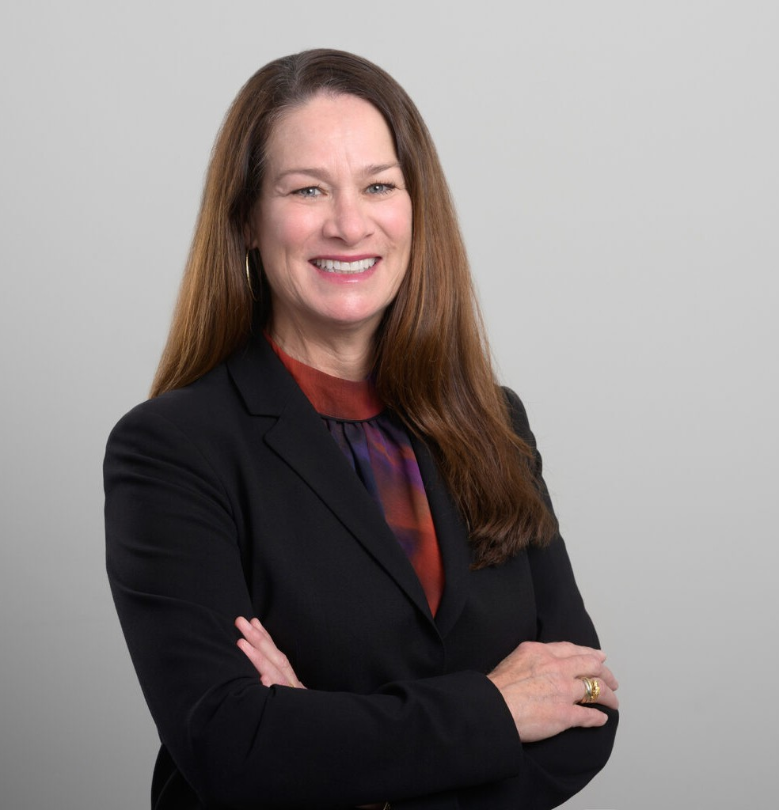

SHARON A. HUERTA

Director

[Insurance Coverage](https://www.fennemorelaw.com/services/insurance-coverage/)

[San Diego](https://www.fennemorelaw.com/contact-us/san-diego/)

P: 619.595.3226 F: 619.231.4372

[shuerta@fennemorelaw.com](mailto:shuerta@fennemorelaw.com)

**SHARON A. HUERTA**

Sharon A. Huerta, a member of the Insurance and Construction practice groups, excels in comprehensive insurance coverage analysis and effective dispute resolution. Her practice encompasses all aspects of litigation, with a focus on insurance coverage litigation and

evaluation, prosecution of bad faith claims, and developer representation.

Sharon’s proficiency extends to appellate writing, where she has been instrumental in drafting briefs for several successful published and unpublished opinions, showcasing her in-depth legal knowledge and skilled argument. Notable cases include Pardee Construction Co. v. Ins. Co. of the West (2000), Emerald Bay Community Assn. v. Golden Eagle Ins. Corp. (2005), and Pulte Home Corp. v. American Safety Indem. Co. (2017).

Her skillset in insurance law, coupled with her knowledge in navigating complex legal disputes, makes her a valuable asset to clients across a broad variety of business and personal sectors. Her role in shaping influential legal decisions further underscores her capabilities as a leading attorney in insurance and construction litigation.

# EDUCATION

J.D., Thomas Jefferson School of Law, *magna cum laude*, 1996

# AREAS OF PRACTICE

Insurance Coverage Construction Law Business Litigation Professional Liability Agribusiness

# REPRESENTATIVE CASES

[*Pardee Construction v. Ins. Co. of the West*](https://www.fennemorelaw.com/wp-content/uploads/2024/12/Pardee-Const-Co-v-Insurance-Co-of-the-West.pdf)[(2000) 77 Cal.App.4th 1340.](https://www.fennemorelaw.com/wp-content/uploads/2024/12/Pardee-Const-Co-v-Insurance-Co-of-the-West.pdf)

[*Emerald Bay Community v. Golden Eagle Ins. Corp.*](https://www.fennemorelaw.com/wp-content/uploads/2024/12/Emerald-Bay-Community-Assn-v-Golden-Eagle-Ins-Corp.pdf)[(2005) 130 Cal.App.4th 1078.](https://www.fennemorelaw.com/wp-content/uploads/2024/12/Emerald-Bay-Community-Assn-v-Golden-Eagle-Ins-Corp.pdf)

[*Pulte Home Corp. v. American Safety lndem. Co.*](https://www.fennemorelaw.com/wp-content/uploads/2024/12/Pulte-Home-Corp-v-American-Safety-Indemnity-Co.pdf)[(2017) 14 Cal.App.5th 1086.](https://www.fennemorelaw.com/wp-content/uploads/2024/12/Pulte-Home-Corp-v-American-Safety-Indemnity-Co.pdf)

# AWARDS AND HONORS

Best Lawyers in America® – Insurance Law

# ARTICLES AND PRESENTATION

Lead Panelist, “Completed Operations: Protecting Your Tail [Coverage],” West Coast Casualty, 2024

Kathleen Cashman-Kramer, Sharon Huerta and Shannon Sweeney Selected as “Business Women of the Year” Finalists by San Diego Business Journal, Firm Newsletter

Yaniv Newman Co-Presents and Sharon Huerta Moderates Upcoming SDCBA Cyber-Risk Program, Firm Newsletter

Sullivan Hill Attorneys Selected For Best Lawyers in America® and Best Lawyers: Ones To Watch® in America, Firm Newsletter

Sullivan Hill Attorneys Attend 2023 West Coast Casualty Construction Defect Seminar, Firm Newsletter

Sharon Huerta to be Panelist in SDCBA Program, “Insurance Law: 2022 Year in Review”, Firm Newsletter

Sharon Huerta Appointed to Chair of the Insurance Law Committee of the CLA Business Law Section, Firm Newsletter

Sharon Huerta to Present at the CLA 2022 Annual Meeting, Firm Newsletter

Sullivan Hill Attorneys Attend 2022 West Coast Casualty Construction Defect Seminar, Firm Newsletter

Sullivan Hill Attorneys Attend 2022 West Coast Casualty Construction Defect Seminar, Firm Newsletter

Sharon Huerta to be a Panelist for SDCBA’s “Insurance Law- 2021 Year in Review” CLE Program, Firm Newsletter

Sharon Huerta to be a Panelist for SDCBA’s “Insurance Law- 2021 Year in Review” CLE Program, Firm Newsletter

Sullivan Hill Attorneys Selected For Best Lawyers in America© and Best Lawyers: Ones To Watch, Firm Newsletter

Four Sullivan Hill Attorneys Recognized as “Women of Influence: 50 Over 50 2021” by the San Diego Business Journal, Firm Newsletter

Sharon Huerta to Present at CLA’s 2021 Business Law Section Insurance Law Symposium, Firm Newsletter

Sharon Huerta to Introduce SDCBA’s 2020 Insurance Law Update Live Webinar, Firm Newsletter

Shareholder Sharon Huerta to Be a Panelist for SDCBA’s Live Webinar on Covid-related Business Interruption Insurance Claims, Firm Newsletter

Shareholder Sharon Huerta to Serve Consecutive Terms on the Boards of the Insurance Law Groups for Both SDCBA and CLA, Firm Newsletter

Shareholder Sharon Huerta to be a Panelist at the 2020 Virtual Annual Meeting of the CLA, Firm Newsletter

Shareholder Sharon Huerta and Attorney Rebecca O’Grady Published by the Insurance/Bad Faith Section of the SDCBA, Firm Newsletter

# PROFESSIONAL AND COMMUNITY ACTIVITIES

Chair, Insurance Law Committee, Business Law Section, California Lawyers Association Vice Chair, Insurance & Bad Faith Law Section, San Diego County Bar Association Member, Claims and Litigation Management Alliance

# ADMISSIONS

California, 1996