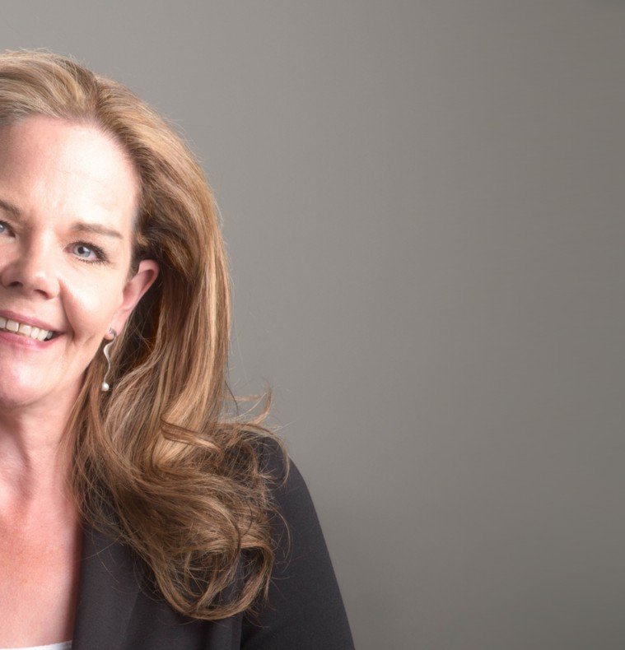

SHAWNA CHARLETON

Paralegal

[Business Litigation](https://www.fennemorelaw.com/services/business-litigation/)

[Reno](https://www.fennemorelaw.com/contact-us/reno/)

P: 775.788.2202 F: 775.786.1177

[scharleton@fennemorelaw.com](mailto:scharleton@fennemorelaw.com)

“

Life is not measured by the number of breaths we take, but by the moments that take our breath away.

- Maya Angelou

”

# OVERVIEW

Shawna Charleton, a litigation paralegal working primarily in our Reno office, focuses on matters including probate and estates, trust litigation and commercial litigation. She also assists corporate clients with various organizational events, such as formation, dissolution, and amendments to their constituent documents, including filings with the Nevada Secretary of

State.

Shawna has been enamored with law since she was in middle school, especially litigation. She compares law to math, looking for the “right” answer. Although she has worked in family law, criminal defense, and assisted with a wide variety of business matters, Shawna admits that there is no adrenaline rush or fight quite like working on litigation matters. She enjoys the fast-pace that litigation often entails, and welcomes the opportunity to find solutions to complex disputes.

Shawna embraces all aspects of her work and the opportunity to learn from the attorneys at Fennemore. “They don’t get frustrated, they welcome the questions, and knowing the answers makes me that much better at what I do.”

In 2019 Shawna was commissioned to perform remote notarizations. When COVID limited personal notarizations Shawna was able to fill this niche and has now done more than 2,000 remote notarizations. At the outset of the COVID economic crisis, Shawna was the only remote notary in northern Nevada. This has been a great asset for the firm and convenience for its

clients.

Of a personal note, Shawna has been a voracious reader since she was a young child. It is not unusual for her to finish two to three books a week. She also enjoys attending rock concerts with her husband, a long-time local radio DJ, and has attended close to 1,000 concerts in the last 14 years.

Shawna is a devoted aunt and treasures her close relationships with her three nephews and one niece, who range in age from four to 20. Shawna lives in Reno with her husband, a stepdaughter, and a menagerie of adored cats.

Business Litigation Trusts & Estates

# EDUCATION

Associates Degree, Science, Truckee Meadows Community College

# AREAS OF PRACTICE

**OTHER EXPERIENCE**

Probate

Business Litigation Trusts & Estates

# PROFESSIONAL AND COMMUNITY ACTIVITIES

Member, National Association of Legal Assistants Approved electronic notary

# ADMISSIONS

*\*Not licensed to the practice of law*