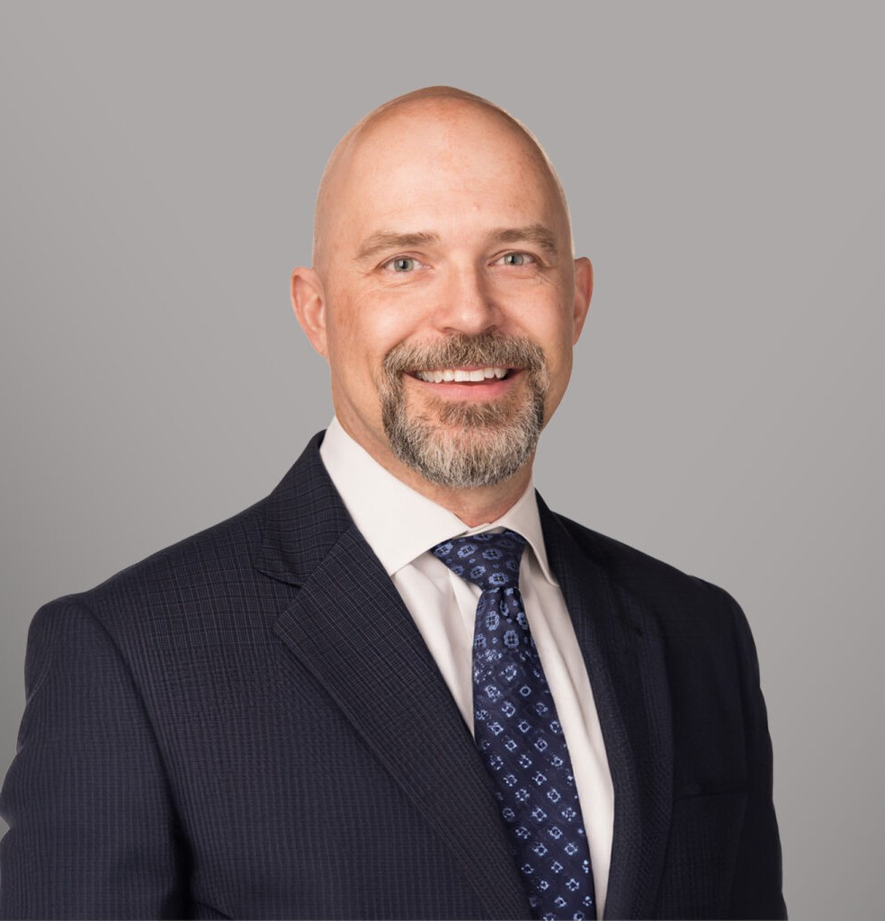

SPENCER A.W. STROMBERG

Director

[Business & Finance](https://www.fennemorelaw.com/services/business-and-finance/)

[Spokane](https://www.fennemorelaw.com/contact-us/spokane/)

P: 509.828.4644 F: 509.455.3718

[sstromberg@fennemorelaw.com](mailto:sstromberg@fennemorelaw.com)

# SPENCER A.W. STROMBERG

Spencer Stromberg is a business and real estate attorney who represents individuals, families, and businesses in all aspects of property and business ownership, including buying or selling residential property; buying, selling, leasing, or developing land or commercial property; new business formation; buying or selling a business; and navigating disputes when they arise.

Spencer also works with his clients to determine the best way to leave their hard-earned assets to their loved ones after death.

Spencer went to law school to become the kind of attorney who could assist his family’s business, which was involved in real estate development, construction, and property

management. He aimed to understand the legal issues facing small companies and sought practical, real-world solutions to help resolve them. Upon graduating and beginning his legal

practice, he discovered that the challenges faced by small business owners are also commonly encountered by individuals and families. He recognized that these clients would eventually need to address the matter of passing their homes, land, investments, and businesses on to family or other loved ones. Spencer is committed to prioritizing client service, with the mission of helping his clients navigate these issues and achieve the best possible outcomes.

A frequent lecturer and author, Spencer has spoken at numerous continuing legal education seminars on key topics such as landlord/tenant law, deed of trust foreclosures, easements, and condominiums. Additionally, he contributes as a co-author to the Washington State Bar Association’s Washington Real Property Deskbook Series, focusing on the ethical issues faced by attorneys in real property matters. Further, Spencer dedicated eight years to serving on the Downtown Spokane Partnership’s Board of Directors and the Business Improvement District Ratepayer Advisory Board. He is a former member of the Executive Committee of the Washington State Bar Association’s Real Property, Probate and Trust Section, demonstrating a broad commitment to advancing the legal profession.

Prior to joining Fennemore, Spencer co-founded Sullivan Stromberg, PLLC, which became

Lucent Law, PLLC. Previously, he worked as in-house counsel, and as a property and project manager for a family-owned real estate development, construction and property management company. Further, he was also a small business owner in the restaurant and brewery industries.

His experiences of running a small business and managing construction projects and commercial property give him a unique understanding of the issues faced by his clients and the ability to strategically form pragmatic solutions to resolving those issues.

# EDUCATION

J.D., University of Washington School of Law B.A., University of Washington

# AREAS OF PRACTICE

Business & Finance Trusts & Estates Real Estate

# ARTICLES AND PRESENTATIONS

Speaker, “Special Considerations for Commercial and Investment Transactions,” Handling Real Estate Transactions from Start to Finish Seminar, April 2019

Speaker, “Terminating or Releasing Easement Options,” Boundary Issues and Easement Law Seminar, December 2016

Speaker, “Creating and Enforcing Easements,” Boundary Issues and Easement Law Seminar, December 2016

Speaker, “Creating and Enforcing Easements,” Boundary Issues and Easement Law Seminar, December 2014

Speaker, “Terminating or Releasing Easement Options,” Boundary Issues and Easement Law Seminar, December 2014

Speaker, “Case Study: Mixed Use Development Projects – A Panel Discussion,” Real Estate Development in Eastern Washington & Idaho Seminar, September 2013

Speaker, “Terminating or Releasing Easement Options,” Boundary Issues and Easement Law Seminar, December 2011

Speaker, “Creating and Enforcing Easements,” Boundary Issues and Easement Law Seminar, December 2011

Speaker, “Commercial Condominiums and Conversions,” Advanced Commercial Leases Seminar, July 2010

Washington State Bar Association, Washington Real Property Deskbook Series: Duties and Responsibilities of the Lawyer (4th Ed., 2009)

Speaker, “Tenant/Borrower Issues in Foreclosure,” Drafting and Foreclosing Deeds of Trust after the Amendments to the Deed of Trust Act Seminar, October 1998

Speaker, “Evictions under the Washington Residential Landlord Tenant Act,” Washington State Bar Association Real Property, Probate and Trust Section Midyear Meeting, June 1995

# PROFESSIONAL AND COMMUNITY AFFILIATIONS

Executive Committee, Washington State Bar Association Real Property, Probate and Trust Section, 2011-2013

Co-Chair, Washington State Bar Association Real Property, Probate and Trust Section Midyear Meeting, 2014

# ADMISSIONS

Washington Idaho

U.S. District Court for Eastern District of Washington

U.S. District Court for Western District of Washington