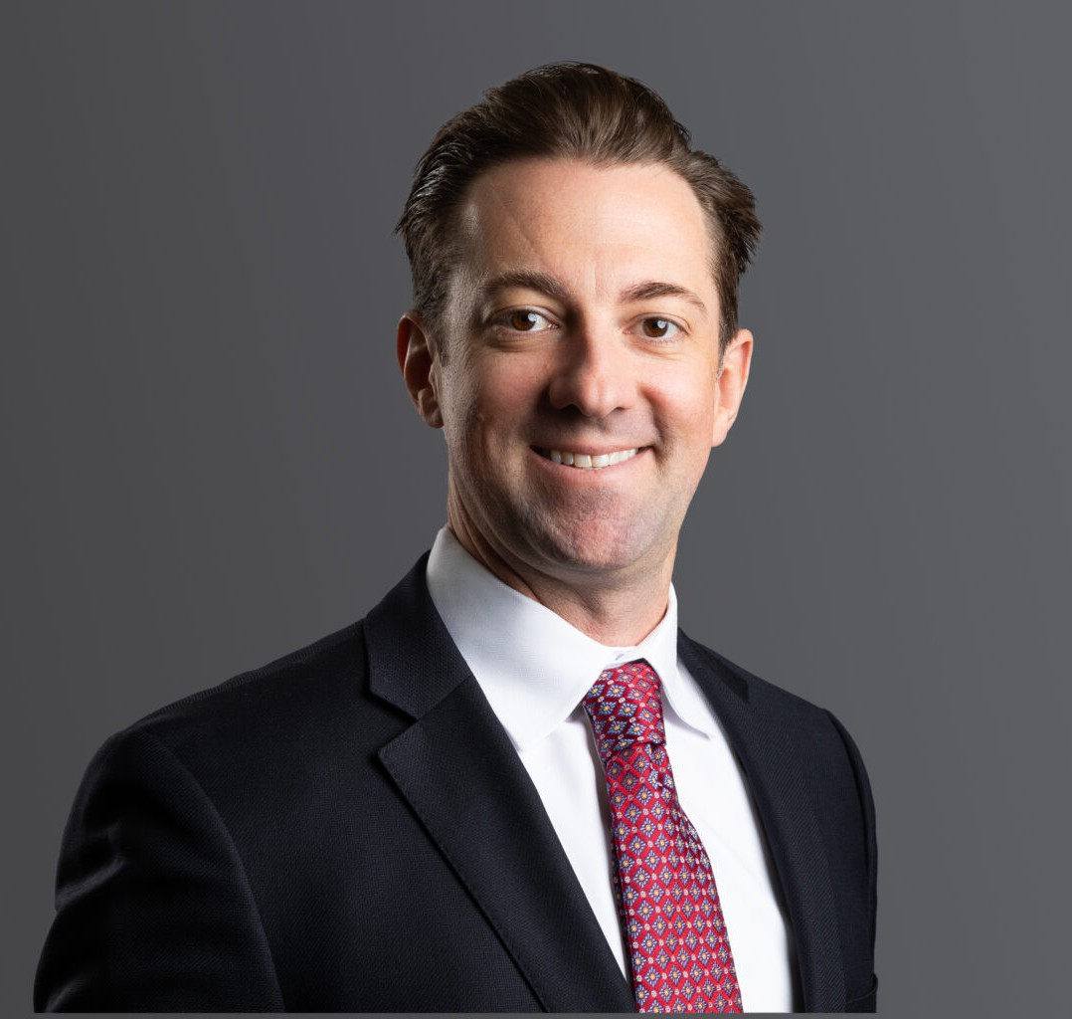

TANNER J. WALLS

Director

[Business Litigation](https://www.fennemorelaw.com/services/business-litigation/)

[Denver](https://www.fennemorelaw.com/contact-us/denver-2/)

P: 303.813.3894 F: 303.291.3201

[twalls@fennemorelaw.com](mailto:twalls@fennemorelaw.com)

# TANNER J. WALLS

Tanner Walls is a trial lawyer who focuses on complex civil litigation. In this capacity, he regularly represents large corporations and small businesses in shareholder disputes, derivative actions,

employment cases, class actions, contract disputes, business torts, trade secret actions, premises liability cases, subrogation matters, and consumer claims. He represented clients on large

employment class actions and multi-district pharmaceutical litigation pending in federal courts as well as statewide coordinated proceedings across the country. Part of his practice involves providing employment law advice to employers and executives in middle market companies and businesses. In this capacity, he provides strategic advice to create proactive solutions for employee management.

Tanner’s versatility as a trial lawyer and breadth of experience provides in-depth experience and expertise that informs his approach to every case and trial, as well as his role as a trusted advisor to his clients.

Since 2018, Tanner has been a member of the teaching faculty of the National Institute for Trial Advocacy (NITA), where he regularly teaches trial skills to NITA students. He is a frequent lecturer and speaker on the role of trial lawyers in sustaining the legal profession through leadership and mentorship on behalf of the Defense Research Institute (DRI), the Colorado Supreme Court’s Attorney Mentor Program (CAMP), and the Colorado Defense Lawyers Association. He also presents on issues related to legal malpractice at seminars and continuing legal education

courses.

Tanner also devotes his time to pro bono efforts through his involvement with the Colorado School Expulsion Pilot Project, where he ensures minor school children who have been expelled receive adequate due process. Tanner also volunteers for the Colorado Poverty Law Project and represents indigent clients pro bono in housing-related matters, helping at-risk individuals and families stay in their homes.

When he is not in courtroom, Tanner is either on his bike or snowboarding somewhere in the mountains of Colorado. He lives in Denver with his wife Alicia and their 140 lbs. dogs, Murphy and Ralphie.

# EDUCATION

J.D., University of Denver Sturm College of Law B.A., University of Colorado

# AREAS OF PRACTICE

Business Litigation

Employment & Labor

# PROFESSIONAL AND COMMUNITY AFFILIATIONS

Colorado Bar Association

Colorado Lawyers Committee, School Expulsion Pilot Project Colorado Poverty Law Project

Denver Bar Association

DRI – Lawyers Representing Business, Regional Director and Board Member National Institute for Trial Advocacy (NITA), Faculty

# AWARDS AND HONORS

[Best Lawyers®, Commercial Litigation and Corporate Law, 2025](https://www.fennemorelaw.com/people/attorneys/tanner-j-walls/Commercial%20Litigation%20and%20Corporate%20Law)

[Best Lawyers® Ones to Watch: Commercial Litigation and Corporate Law, 2024](https://www.bestlawyers.com/united-states/colorado/denver)

# ARTICLES AND PRESENTATIONS

Presenter, “Mastering the Effective Cross Examination,” NITA Trial Skills Semiar, November 1, 2021

Presenter, “Enhance Creative Thinking Among Leadership Team,” DRI Leadership Conference, January 2020

Presenter, “CAMP Pilot Project – Co-Counseling Civil Jury Trials,” CDLA Annual Conference, July 2016

Presenter, “PED Talk,” National Mentoring Conference, May 2016

Presenter, “Do’s and Don’ts of Legal Malpractice,” CDLA CLE, December 2012

# ADMISSIONS

Colorado New York Wyoming

U.S. District Court – District of Wyoming

U.S. District Court – District of Colorado

U.S. District Court – Southern District of New York