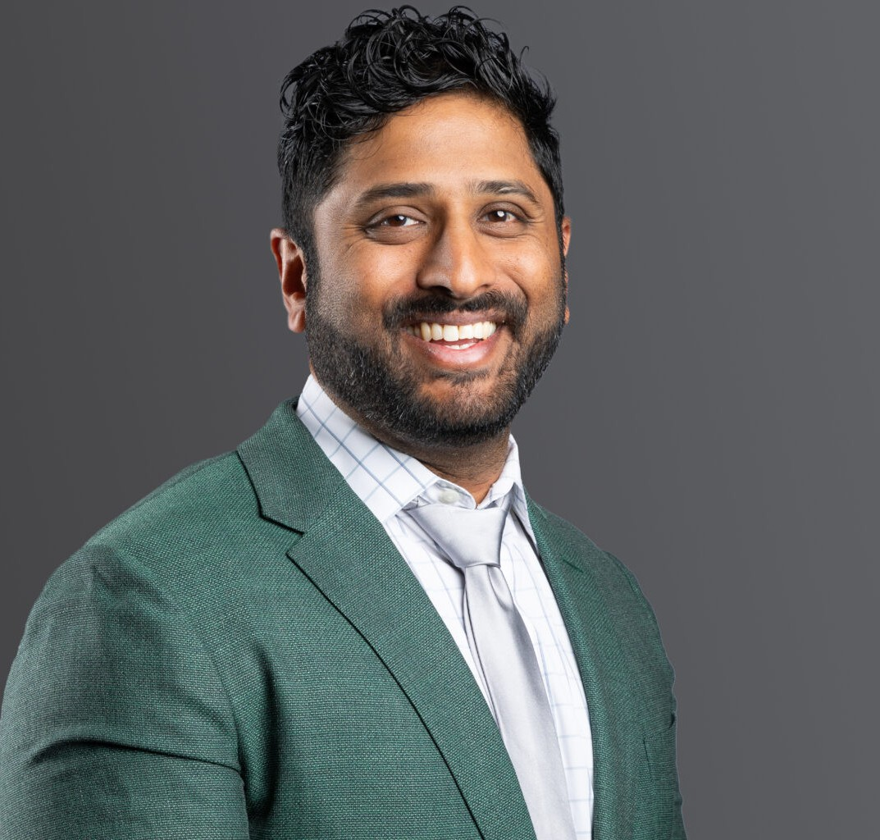

VIKRAMA S. CHANDRASHEKAR

Of Counsel

[Business Litigation](https://www.fennemorelaw.com/services/business-litigation/)

[Denver](https://www.fennemorelaw.com/contact-us/denver-2/)

P: 303.813.3810

F: 303.291.3201

[vchandrashekar@fennemorelaw.com](mailto:vchandrashekar@fennemorelaw.com)

# VIKRAMA S. CHANDRASHEKAR

Vika is a member of the Business Litigation team and handles a wide variety of civil and commercial litigation matters across a wide range of industries, including in property, real estate, landlord/tenant, and cannabis-related disputes, complex business and shareholder/membership disputes, construction matters, and with municipal/governmental issues. He has significant experience in all facets of litigation, from early case resolution to trials and arbitrations. Vika is

also a member of the firm’s Financial Restructuring team, and has experience handling matters in bankruptcy and receivership, with a focus on creditors’ rights. He has successfully litigated adversary proceedings and counseled clients through complex bankruptcy issues under both Chapter 7 and Chapter 11 of the Bankruptcy Code. He enjoys the intricacies of trial work and relishes the opportunity to appear in the courtroom.

Previously, Vika worked at a local firm where he represented cities, municipalities, school districts, and other public entities involving civil rights and tort claims. In this role, Vika defended

government entities and employees against a variety of claims in federal and state court. At Fennenmore, he leverages this experience for the benefit of clients who seek to navigate issues with their local governments.

Additionally, Vika gained experience working for the Denver City Attorney’s Office and the 20th Judicial District Attorney’s Office. In his spare time, Vika enjoys tennis, basketball, hiking, literature, film, trivia, coaching mock trial, and spending time with his one-year old daughter and three dogs. He speaks Spanish and intermediate Tamil.

# EDUCATION

J.D., University of Colorado

University of Colorado Law Review, Associate Editor B.A., Plan II Honors Program, University of Texas, Austin

# AREAS OF PRACTICE

Business Litigation Cannabis Business

Financial Restructuring Eminent Domain

# ARTICLES AND PRESENTATIONS

Quoted, “[Federal government enacting new tipping rule for restaurants,](https://www.bizjournals.com/denver/news/2021/11/22/federal-tip-pooling-rule-colorado-restaurants.html?utm_source=st&utm_medium=en&utm_campaign=ae&utm_content=de&ana=e_de_ae&j=25798219&senddate=2021-11-22)”

*Denver Business Journal*, November 2021

Guest Speaker, “[Episode 24 – South Asian Bar Association and EDI Education](https://www.cobar.org/Podcast/Gettin-Legal-With-It#9064772-episode-24--vikrama-chandrashekar---south-asian-bar-association-and-edi-education),”

Colorado Bar Association – Young Lawyer Division’s “Gettin Legal With It” Podcast, September 2021

Co-Author, “[Evictions in the Time of COVID-19](https://crej.com/news/working-with-troubled-tenants-in-the-time-of-covid-19/),” *Colorado Real Estate Journal*, April 2020

Panelist, “Decision Making During Adversity: Pathways to Pivot,”Colorado Brewers Guild Webinar, March 2020

Co-Author, “[Practical Considerations Surrounding the Applicability of Force Majeure Clauses](https://www.moyewhite.com/news-insights/blog/march-2020/practical-considerations-surrounding-the-applicabi) [in the Midst of COVID-19](https://www.moyewhite.com/news-insights/blog/march-2020/practical-considerations-surrounding-the-applicabi),” *Firm Blog*, March 2020

Co-Author, “[The Evolving Legal Landscape of Employee Cannabis Use](https://www.marijuanaventure.com/drug-test/),”

*Marijuana Venture,* August 2019

Author, “[Getting Even Less Than What They Paid For: The Plight of Generic Drug Consumers](http://lawreview.colorado.edu/wp-content/uploads/2015/07/11.-86.1-Chandrashekar_Final-updated.pdf) [Under the Levine-Mensing Dichotomy](http://lawreview.colorado.edu/wp-content/uploads/2015/07/11.-86.1-Chandrashekar_Final-updated.pdf),” 86 U. Colo. L. Rev. 259 (2014)

# PROFESSIONAL AND COMMUNITY AFFILIATIONS

Volunteer, CHBA Project Safeguard Member, Colorado Bar Association

Former President, South Asian Bar Association of Colorado, 2021 Coach/Mentor, University of Colorado School of Law Barristers’ Council

# AWARDS AND HONORS

Best Lawyers® Ones to Watch, Administrative/Regulatory Law, Commercial Litigation, and Energy Law, 2021 -2025

Best Lawyers® Ones to Watch, Litigation – Bankruptcy, 2023-2025

Colorado Super Lawyers Rising Star: Civil Litigation – Defense, 2021-2024

# ADMISSIONS

Colorado

U.S. Court of Appeals for the Tenth Circuit

U.S. District Court – District of Colorado

# LANGUAGES

Spanish Intermediate Tamil