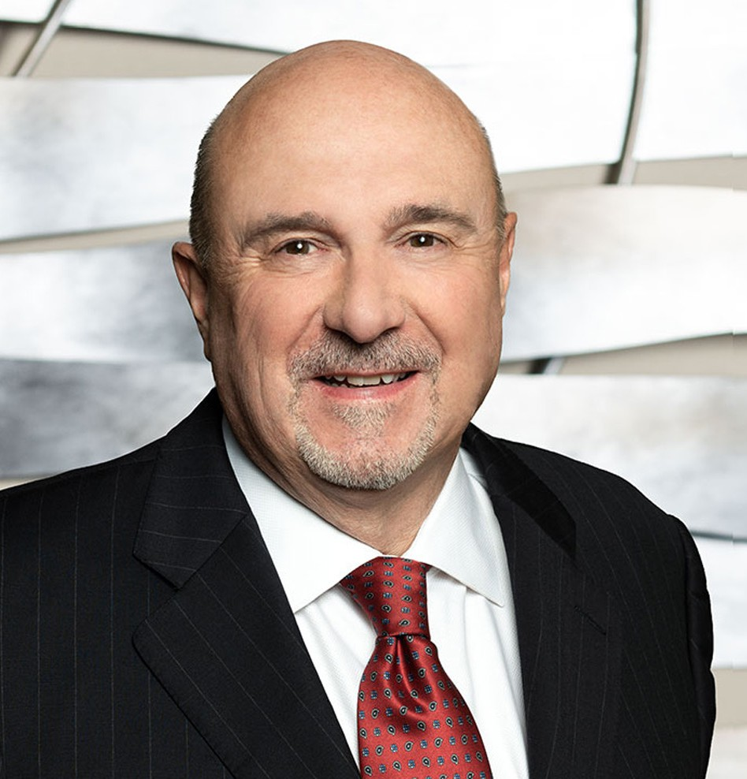

WM. LANIER THOMAS

Of Counsel

[Trusts & Estates](https://www.fennemorelaw.com/services/trusts-estates/)

[Fresno](https://www.fennemorelaw.com/contact-us/fresno/)

P: 559.432.4500 F: 559.432.4590

[lthomas@fennemorelaw.com](mailto:lthomas@fennemorelaw.com)

**WM. LANIER THOMAS**

Lanier Thomas practices in the areas of strategic wealth conservation, business continuity planning, charitable giving and asset protection. He focuses his practice on integrating sophisticated estate and tax planning with business succession planning. His practice also includes the transfer of family wealth and plan administration.

Lanier decided to become a lawyer at an early age, and his gift has always been to help people and solve problems. He likes to think creatively, and the estate planning field provides those challenges and opportunities. For forty years, Lanier has been involved with clients from all walks of life, helping them to bring order to their family, legal and financial affairs. Using living

trusts, a wide variety of business entities and advanced strategies, he has helped clients convert paper profits to increased cash flow, with the ability to maintain control and pass on their values to the next generation, while minimizing estate, gift and income taxes. He truly enjoys listening to the families he serves and learning their stories and history. As an active listener, he likes to draw out the details of each family. Lanier believes that if he can expand his clients’ horizons of what can be achieved through planning, and give them peace of mind, he has truly done his job. He enjoys taking otherwise complicated strategies and making them simple and easy to

understand. In addition to practicing law, he is actively involved in educating insurance

professionals, lawyers, financial advisors, CPAs, and stockbrokers in basic and advanced estate planning concepts.

To relax and recharge, Lanier enjoys the outdoors, fly fishing, hiking, and skiing. He is also an avid reader of biographies and history.

# EDUCATION

J.D., SMU Dedman School of Law

B.A., with high honors, English Literature and Political Science, Westmont College

# AREAS OF PRACTICE

OTHER EXPERIENCE

Business Succession Charitable Planning

Strategic Wealth Preservation Trusts & Estates

Estate Planning

# AWARDS AND HONORS

AV® Preeminent™ Peer Review Rated (the highest rating available), by Martindale-Hubbell

# ARTICLES AND PRESENTATIONS

Co-author, “Business Succession Planning,” Treatise California Continuing Education of the Bar

# PROFESSIONAL AND COMMUNITY ACTIVITIES

Member, California Bar Association, Trusts and Estates Section

Member, Fresno County Bar Association, Estate Planning and Probate Section

Founding Member, Wealth Counsel, LLC, a national network of estate planning attorneys Member, Fresno Estate Planning Council

Partnership for Philanthropic Planning

Co-Chair of Major Gifts Committee, Fresno Rescue Mission Audit Committee, Valley Public Television, lnc.

Former Member, Board of Directors, Fresno Art Museum

# ADMISSIONS

California

U.S. District Court, Eastern District of California