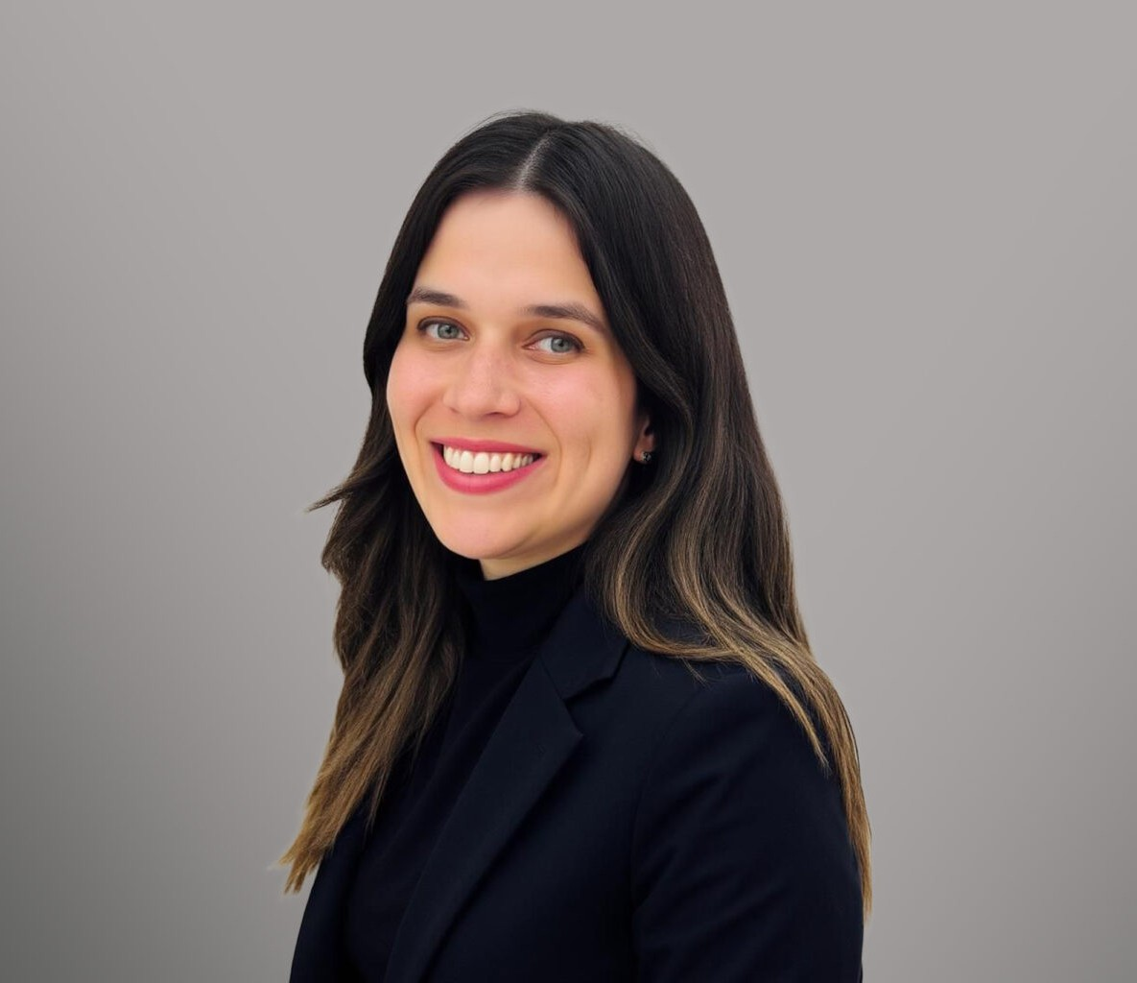

APRIL HERRERA

Paralegal

[Trusts & Estates](https://www.fennemorelaw.com/services/trusts-estates/)

[Oakland](https://www.fennemorelaw.com/contact-us/oakland/)

P: 510.834.6600 F: 510.834.6600

[aherrera@fennemorelaw.com](mailto:aherrera@fennemorelaw.com)

“

Whatever you choose to do, leave tracks. That means don’t do it just for yourself. You will want to leave the world a little better for your having lived.

Ruth Bader Ginsburg

”

# APRIL HERRERA

April Herrera is a dedicated paralegal with extensive experience in probate estate

administration, trust administration, and estate planning. Her legal career began unexpectedly after graduating from San Francisco State University a year ahead of schedule. Seeking hands- on experience in the legal field before committing to attend law school, she joined a San Francisco-based law firm in 2013. It was there that she discovered her passion for the legal

profession.

Encouraged by her then-employer, Susanne Cohen, April pursued a paralegal certificate while working full-time and obtained her certification from Skyline College in 2015. Since then, she has been committed to assisting clients through complex estate and trust administration matters, ensuring a seamless process during some of life’s most challenging moments.

April is currently furthering her legal education as a Flex JD student at Santa Clara University School of Law, where she is pursuing her Juris Doctor (JD) degree, with an anticipated graduation in Fall 2027. She aspires to specialize in trusts and estates law as an attorney.

Beyond her professional pursuits, April enjoys photography, cycling and rock climbing as ways to recharge and maintain balance.

Trusts & Estates

# EDUCATION

B.A., *magna cum laude and Dean’s List,* San Francisco State University Paralegal Certificate, Skyline College

# AREAS OF PRACTICE

Trusts & Estates

# PROFESSIONAL AND COMMUNITY ACTIVITIES

Member, Paralegal Advisory Committee, Skyline College

# ADMISSIONS

*\*Not licensed to the practice of law*