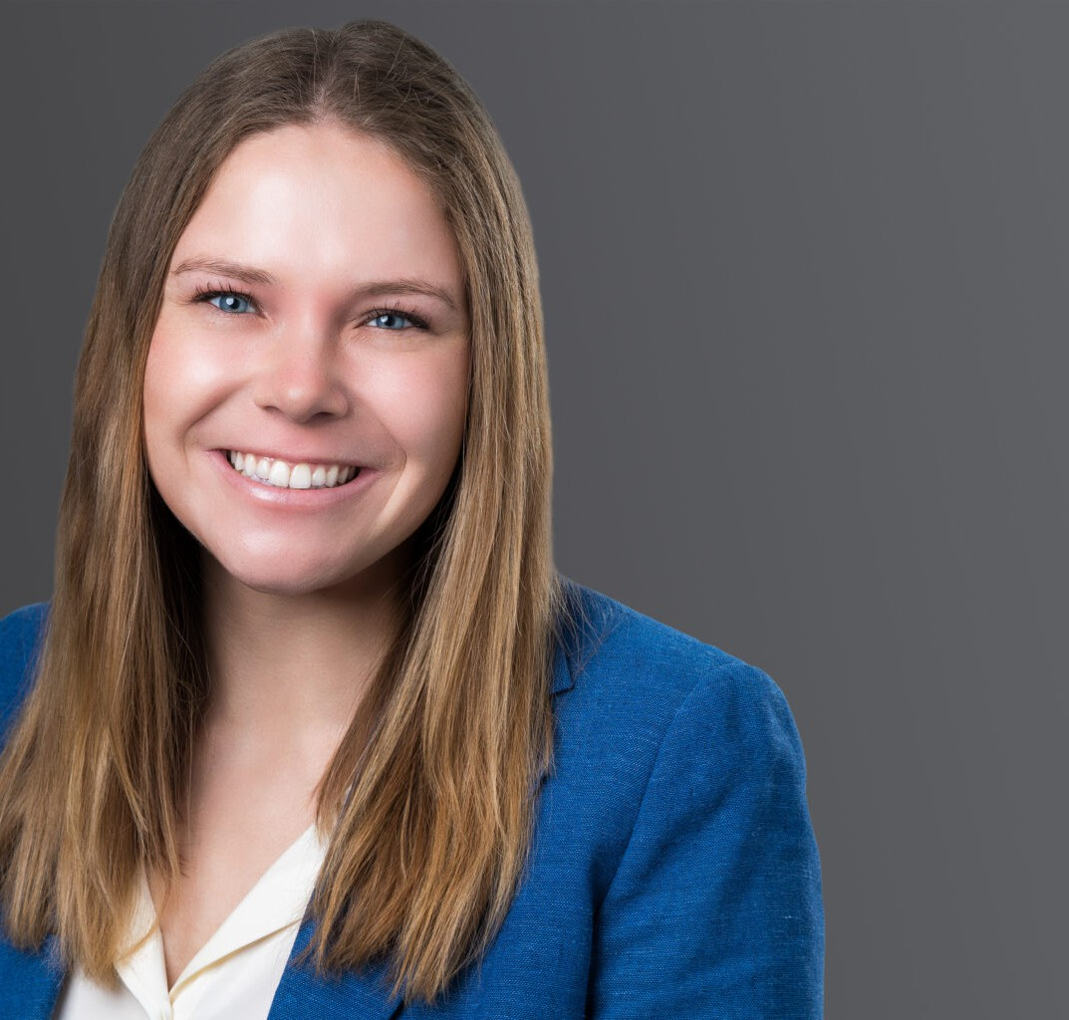

CLAIRE A. MACCOLLUM

Associate

[Business Litigation](https://www.fennemorelaw.com/services/business-litigation/)

[Phoenix](https://www.fennemorelaw.com/contact-us/phoenix/)

P: 602.916.5402

F: 602.916.5999

[cmaccollum@fennemorelaw.com](mailto:cmaccollum@fennemorelaw.com)

# CLAIRE A. MACCOLLUM

Claire A. MacCollum is an associate attorney in Fennemore’s [Business Litigation](https://www.fennemorelaw.com/services/business-litigation/) group. In her practice, Claire advises clients on complex commercial litigation and employment issues ensuring compliance with federal and state laws, such as the WARN Act. She also has experience negotiating settlement agreements related to employment discrimination claims.

Prior to joining Fennemore, Claire worked as an associate attorney in the Boston area. She also worked as a Housing Unit Legal Intern at Northeast Legal Aid, where she assisted the supervising attorney in preparing and attending client mediation sessions in fault and no-fault eviction

cases, conducted research, and investigated and organized discovery documents related to various housing issues, particularly regarding the CDC eviction moratorium. Additionally, she served as a law clerk for a small Arizona law firm where she gathered and analyzed discovery in civil rights cases.

# EDUCATION

J.D., Boston College Law School

B.A., *magna cum laude*, University of Richmond

# AREAS OF PRACTICE

Business Litigation

# PROFESSIONAL AND COMMUNITY AFFILIATIONS

Intern, Office of Congressman Ruben Gallego, Washington, DC Volunteer, Chicanos Por La Causa, Phoenix, AZ

# ADMISSIONS

Arizona Massachusetts

# LANGUAGES

Spanish