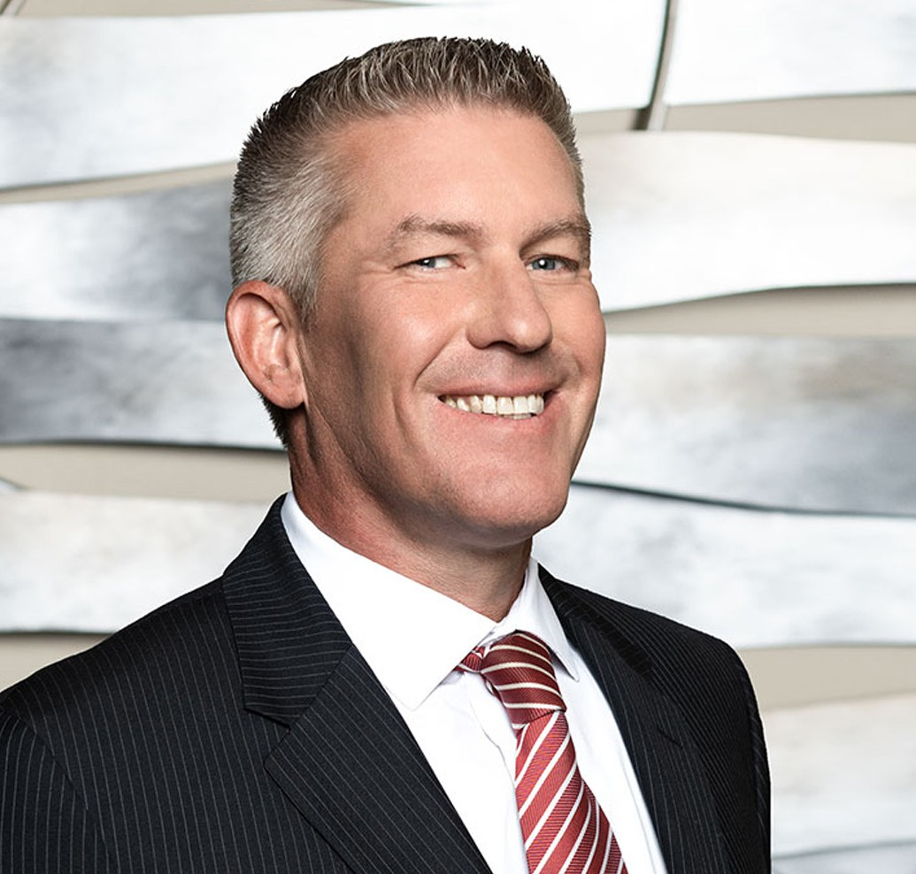

DAVID D. SCHNEIDER

Director

[Business Litigation](https://www.fennemorelaw.com/services/business-litigation/)

[Fresno](https://www.fennemorelaw.com/contact-us/fresno/)

P: 559.432.4500

F: 559.432.4590

[dschneider@fennemorelaw.com](mailto:dschneider@fennemorelaw.com)

“

The harder you work, the luckier you get.

-Gary Player

**DAVID D. SCHNEIDER**

”

David Schneider is an attorney and Vice-Chair in our business litigation practice group. David specializes in litigation arising from complex business, shareholder and partnership disputes, real estate transactions and leases, and construction projects. In addition, David provides California Proposition 65 compliance counseling and vigorous defense representation to manufacturers,

distributors, and retailers in a wide range of industries that are facing Proposition 65 issues, claims, and lawsuits.

David routinely handles civil disputes from a pre-litigation stage through arbitration and trial.

David’s pre-trial experience includes extensive law and motion drafting and courtroom advocacy, hundreds of depositions, and representing clients in scores of mediations that resulted in advantageous resolutions prior to trial.

David became a lawyer because he believes in the rule of law. His clients turn to him for assistance because he works tirelessly to help them achieve their objectives in a practical and efficient manner. David’s clients include large and small business owners in many industries, including agriculture, real estate, insurance, and construction.

David unplugs by coaching his kids’ baseball teams and spending time with his family and friends.

# EDUCATION

J.D., San Joaquin College of Law

B.S., California State University, Fresno

# AREAS OF PRACTICE

**OTHER EXPERIENCE**

Construction Litigation Real Estate Litigation Business Litigation

# AWARDS AND HONORS

*Best Lawyers in America®,* Litigation – Real Estate, 2025

*Northern California Super Lawyers®*, 2014-2023, 2025

# PROFESSIONAL AND COMMUNITY ACTIVITIES

Member, State Bar of California

Member, California Bar Association, Litigation Section

Member, Fresno County Bar Association, Real Property and Construction Law Sections

Past President, and current Member of Board of Governors, Association of Business Trial Lawyers, San Joaquin Valley Chapter

# ADMISSIONS

California

U.S. District Court, Central District of California

U.S. District Court, Eastern District of California