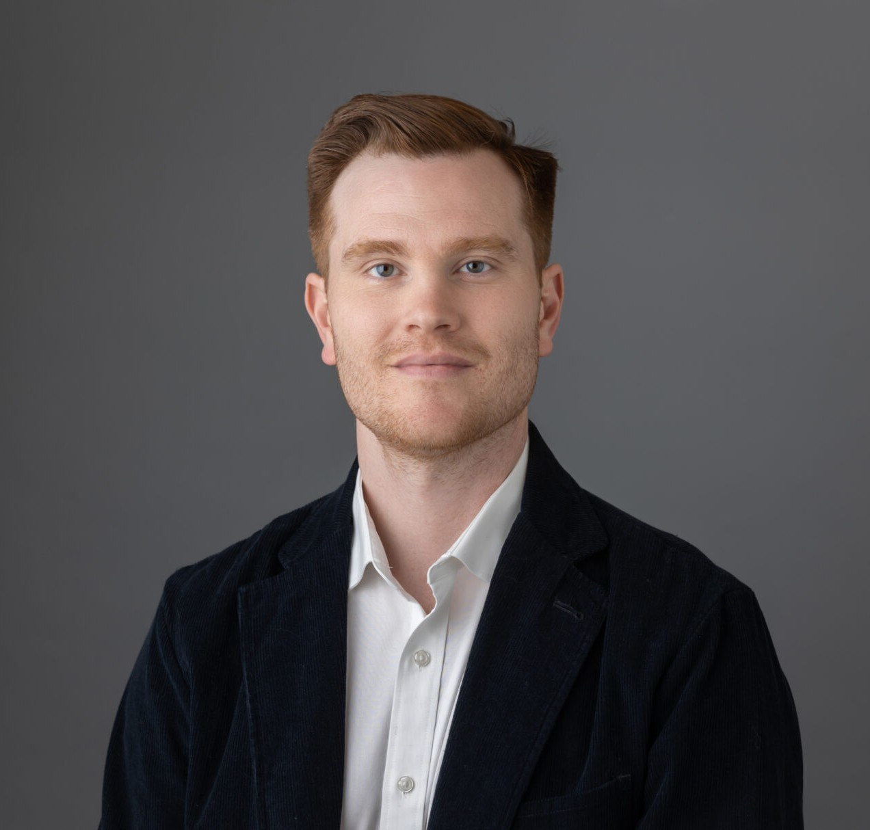

DAVID F. MONSOUR

Director

[Trusts & Estates](https://www.fennemorelaw.com/services/trusts-estates/)

[Oakland](https://www.fennemorelaw.com/contact-us/oakland/)

P: 510.834.6600

F: 510.834.1928

[dmonsour@fennemorelaw.com](mailto:dmonsour@fennemorelaw.com)

# DAVID F. MONSOUR

David practices on behalf of his clients in the area of trusts and estates litigation where he represents and counsels trustees, beneficiaries, and professional fiduciaries through all phases of T&E disputes, from pre-litigation matters through trial.

David attended undergrad at the University of Texas at Austin, where he graduated beta

gamma sigma with a Bachelor of Business Administration from the Red McCombs School of Business. David attended law school and received his Juris Doctor from the University of

California College of the Law, San Francisco (formerly UC Hastings). While in law school, David externed for the Honorable Edward J. Davila of the United States District Court, Northern District of California and for the Office of the Circuit Executive for the Ninth Circuit Court of Appeals in San Francisco.

As a legal professional, David assists clients in solving difficult, and often times emotional

problems. His practice thrives on developing and maintaining trusted relationships with each client, and crafting client-specific legal strategies. David’s client-specific and results-oriented

approach helps his clients achieve their ultimate goals, whether through reaching an amicable settlement or diligently litigating and defending against claims at trial or on appeal. David has been recognized as a Northern California Rising Star by Super Lawyers and by Best Lawyers in

America in the area of trusts and estates litigation.

In his free time, David enjoys volunteering, writing about films, live music, and park days. He lives in San Francisco with his wife and their cat, Frankie.

# EDUCATION

J.D., University of California College of the Law, San Francisco (formerly UC Hastings College of the Law)

B.B.A., The University of Texas at Austin, Red McCombs School of Business

# AREAS OF PRACTICE

Trusts & Estates

Estate Litigation

# ARTICLES AND PRESENTATIONS

Presenter, “Trusts and Estates Career Panel and Lunch at UC Law San Francisco,” California Lawyers Association, Trusts and Estates Executive Committee, March 27, 2024

Update Co-Author for California Trust and Probate Litigation (Cal CEB), Chapter 20 (Trust Contests) and Chapter 21 (Breach of Trust), 2023-2024

Co-Presenter, EBTEL Speaker Event, “What Estate Planners Should Know – a Litigator’s

Perspective, Tips, Strategies, and Pitfalls to Avoid for Estate Planners to Prevent or Minimize Litigation,” East Bay Trusts and Estates Lawyers, August 9, 2023

[Featuring, “Conversation On Lessons Learned & Life In The Law With Attorney David Monsour,”](https://www.fennemorelaw.com/i-feel-fortunate-to-work-with-such-phenomenal-attorneys-and-amazing-human-beings/) [Fennemore Blog, August 17, 2023](https://www.fennemorelaw.com/i-feel-fortunate-to-work-with-such-phenomenal-attorneys-and-amazing-human-beings/)

Presenter, “Trusts and Estates Career Panel at Berkeley Law,” California Lawyers Association, Trusts and Estates Executive Committee, March 22, 2023

[Featuring, “Fennemore attorney David Monsour Shares Insights on Estate Planning, Tips for](https://www.bizjournals.com/sanfrancisco/news/2024/08/01/fennemore-avoiding-estate-litigation.html) [Mitigating Trusts and Estates Litigation,” San Francisco Business Times, August 1, 2024](https://www.bizjournals.com/sanfrancisco/news/2024/08/01/fennemore-avoiding-estate-litigation.html)

# AWARDS AND HONORS

*Best Lawyers in America*®, Ones to Watch – Litigation, Trusts and Estates, 2024 – 2025 Rising Star, *Northern California Super Lawyers*®, 2018-2024

# PROFESSIONAL AND COMMUNITY ACTIVITIES

Member, State Bar of California (SBN #301448) Member, East Bay Trusts and Estates Lawyers Member, Alameda County Bar Association Member, Contra Costa County Bar Association Member, San Francisco County Bar Association

Member, Trusts and Estates Section, California Lawyers Association Member, Fennemore Community Service & Outreach Committee, Oakland Volunteer, Operation Dignity

Volunteer, Alameda County Community Food Bank

# ADMISSIONS

California