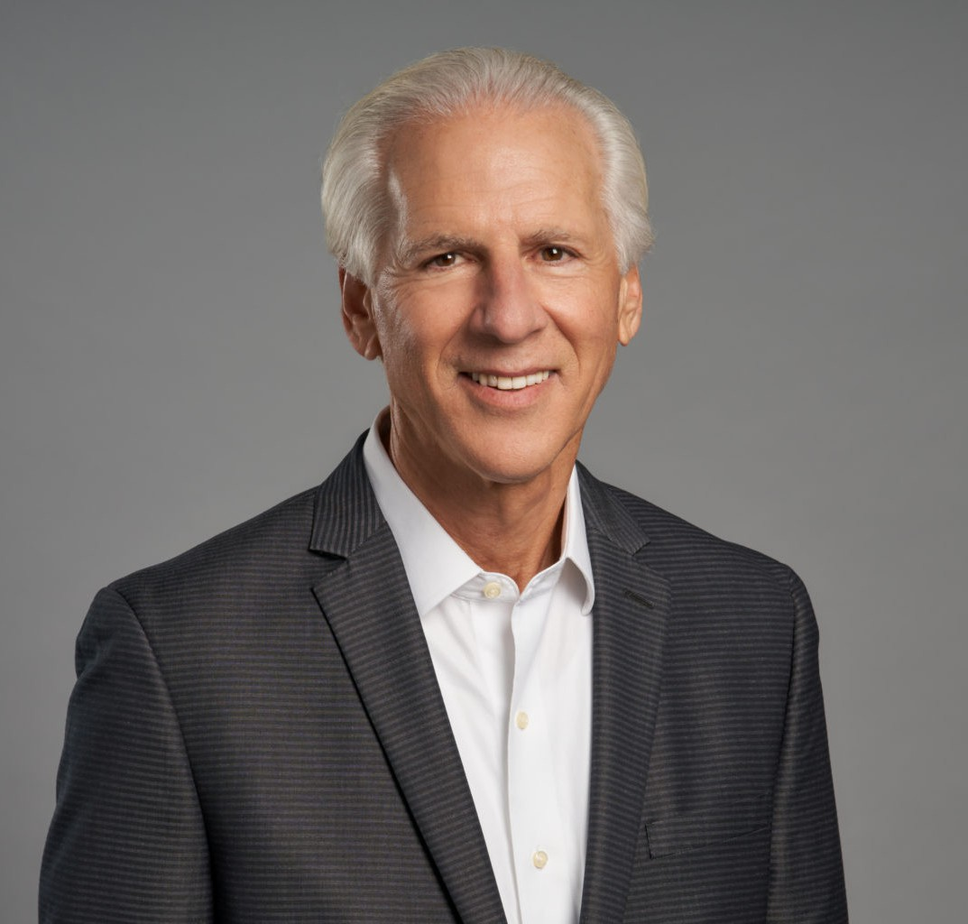

DAVID GOLDMAN

Director

[Employment & Labor](https://www.fennemorelaw.com/services/employment-and-labor-relations/)

[Oakland](https://www.fennemorelaw.com/contact-us/oakland/)

P: 510.834.6600 F: 510.834.1928

[dgoldman@fennemorelaw.com](mailto:dgoldman@fennemorelaw.com)

“

Just Win Baby!

- Al Davis, former general partner, Oakland/Las Vegas Raiders.

**DAVID GOLDMAN**

”

With more than 40 years of civil trial experience, David handles a wide array of business litigation, employment law and competitive business practices counseling and litigation. Previously, David served as a Deputy City Attorney for the City and County of San Francisco for four years.

David represents businesses and their owners and shareholders in commercial and business

disputes, including derivative shareholder actions, involuntary corporate dissolutions, breach of loyalty and fiduciary duty claims, and trade and contract disputes in both arbitration forums and civil courts.

David counsels clients in complying with federal, state and local employment laws and defends employers in wage and hour regulation disputes as well as employment lawsuits and discrimination claims, including age discrimination, sexual harassment and battery, pregnancy discrimination, racial discrimination, disability discrimination, family leave disputes and wrongful termination cases. David also assists clients with matters related to unfair competition, trade secrets, and non-competition agreements involving businesses and employees.

David regularly represents property owners and tenants in disputes involving equal access to business premises and services by individuals with disabilities under the Americans with Disabilities Act and the related California Unruh Civil Rights Act and Disabled Persons Act. He guides clients to find solutions to access barriers and resolve related lawsuits.

David is a lecturer and author on various employment law for various organizations.

# EDUCATION

J.D., University of California, San Francisco, Hastings College of the Law

B.A., Michigan State University, with honors

# AREAS OF PRACTICE

Employment & Labor Business Litigation Real Estate

# REPRESENTATIVE CASES

**Real Estate Sales and Broker Dispute:** Successfully prosecuted for his client, a co-owner of commercial real estate four purchase and sales agreements, and defended against claims of breaches of fiduciary duties as the property manager, following a 3-week jury trial. Client received a large financial award on the sales agreements and defeated all claims of wrongdoing while performing services as the real estate property manager.

**Landslide and Storm Water Drainage Dispute:** Successfully obtained a multi-million dollar settlement with two public entities and a townhouse development for damage caused to

client’s real property as a result of a landslide and inadequate storm water drainage design issues.

**Trade Secrets Dispute:** Successfully represented in lawsuit by a startup software company against prominent Silicon Valley company for violating trade secrets and software license agreement

**Shareholder Dispute:** Successfully represented organics company against lawsuit by dissident shareholder and director of breaches of fiduciary duties, failure to allow inspection of corporate records, misappropriation of corporate opportunities, involuntary dissolution and wrongful termination of employment claims

**Shareholder Dispute:** Successfully represented wholesaler distributor and reseller of cellular phone services in a lawsuit against claims by dissident shareholder and director of breaches of fiduciary duties, misappropriation of corporate opportunities and involuntary dissolution

**Executive Employment Dispute:** Successfully represented venture capital fund and its majority shareholder in a lawsuit through trial that was filed by its former CEO and a minority shareholder alleging violation of his employment contract, unpaid severance and wages, and breach of an agreement to repurchase CEO’s shares in the venture fund

**Physician Employment Contract Dispute:** Successfully represented employee physician in

contract dispute brought by her former employer. a medical corporation, and defeated all claims against the physician and also prevailed after 4 day arbitration to obtain money damages on her cross-complaint, following 4-days of arbitration hearings.

**Commercial Lease Dispute:** Successfully obtained a jury verdict at trial while representing a commercial tenant against the landlord and adjoining tenant for breach of the commercial lease and fraud relating to exclusive parking areas on the property

**Wrongful Termination Defense:** Successfully represented physician and surgery center against claims by former nurse for alleged wrongful termination, breaches of public policy rights, unpaid wages, penalties and interest

**Commercial Dispute:** Successfully represented an independent manufacturer of medical equipment in lawsuit against wholesaler/dealer who filed to fulfill contract order or pay for equipment manufactured and delivered by successfully obtaining a prejudgment writ of

attachment in excess of $1 million that effectively forced the wholesaler/dealer to immediately settle the lawsuit and paid the full amount owed

**Employer Defense:** Successfully represented a medical staffing company and a surgeon in a

lawsuit brought by the surgery scheduler after she was terminated from employment while she was on a disability leave of absence as a result of a reduction of workforce business decision.

**Real Property Dispute:** Successfully represented public entity through trial and multiple legal appeals to defeat claim that a developer had an option to purchase valuable real property worth in excess of $25 million

# AWARDS AND HONORS

AV® Preeminent™ Peer Review Rated (the highest rating available), by Martindale-Hubbell

# ARTICLES AND PRESENTATIONS

[Co-Author, “Access Denied: California Appellate Court Refuses to Apply the Americans with](https://www.fennemorelaw.com/access-denied-california-appellate-court-refuses-to-apply-the-americans-with-disabilities-act-to-web-only-businesses/) [Disabilities Act to Web-Only Businesses,” Fennemore Wendel, October 12, 2022](https://www.fennemorelaw.com/access-denied-california-appellate-court-refuses-to-apply-the-americans-with-disabilities-act-to-web-only-businesses/)

[Author, “California Court Clarifies Personal Liability of Managers for Unpaid Wages,”](https://www.fennemorelaw.com/california-court-clarifies-personal-liability-of-managers-for-unpaid-wages/) [Fennemore Wendel, July 19, 2022](https://www.fennemorelaw.com/california-court-clarifies-personal-liability-of-managers-for-unpaid-wages/)

Author, “California Supreme Court Holds That Failing to Pay and Account for Missed Meals and Rest Periods has a Cascade of Financial Consequences,” Linkedin, July 19, 2022

Speaker, “Untangling the COVID Mess and Other Employer Challenges for California Businesses in 2022,” Client Presentation, January 19, 2022

Speaker, “Returning to the Workplace: COVID-19 and New Laws for 2021,” Client Presentation, January 21, 2021

Speaker, “2020 Employment Law Update,” Client Presentation, January 22, 2020

Speaker, “What CEOs, In-House Counsel, and Senior Execs Need to Know about 2019’s New Employment Laws,” Client Presentation, January 15, 2019

Speaker, “Managing Your Employees: Keeping it Legal,” Oakland Business Week, May 2018

Author, “It’s as Simple as ‘ABC’ – Determining Whether Workers are Independent Contractors or Employees,” Client Update, May 2018

Author, “What a Day of Rest Means in California,” Today’s General Counsel, August/September 2017

Speaker, “The Leave of Absence Puzzle,” Client Presentation, September 20, 2017

Speaker, “Top 10 Employment Law Changes for 2017,” Brown & Brown of California Seminar, April 2017

Speaker, “Fighting the ADA Wars,” Building & Office Managers Association – Oakland/East Bay, August 2016

Author, “What Relief Does New Disability Access Legislation Provide for Businesses?” Client Update, June 2016

Author, “Businesses Must Adapt to the Tidal Wave of Wage Legislation,” Client Update, May 2016

Speaker, “New Employment Laws in 2016 That Will Impact Your Business,” Client Seminar, November 2015

Speaker, “What You Need To Know About New Employment Laws,” 2012-2015

Speaker, “Sexual Harassment Training for Supervisors,” Construction Financial Management Association, January 2013

Author, “2012 Disability Access Law Helps Business Owners and Tenants,” Client Update, December 2012

Author, “New Hire Employee Form Revised by Labor Commissioner,” Client Update, April 2012 Author, “Brinker Court Clarifies Meal and Rest Period Obligations,” Client Update, April 2012 Author, “New Employee Poster Requirement Delayed,” Client Update, January 2012

Author, “Labor Commissioner Announces New 2012 Employee Form,” Client Update, December 2011

Author, “New Penalties for Misclassifying Workers as Independent Contractors,” Client Update, November 2011

Author, “New Limits on Employer Rights to Obtain Credit Reports,” Client Update, November 2011

Author, “New Employment Law Requires Written Notice to New Employees,” Client Update, November 2011

Author, “New Law Requires Employers to Provide Group Health Insurance to Employees on Pregnancy Leave,” Client Update, November 2011

Author, “Arbitrating Disputes With Employers: Three 2011 Cases Refine Standards for Arbitration Agreements in California,” Client Update, August 2011

Author, “Missed Meal and Rest Periods in One Workday Constitute Two Violations,” Client Update, March 2011

Author, “Tip Pooling Law: Employees Cannot Sue,” Client Update, August 2010

# PROFESSIONAL AND COMMUNITY ACTIVITIES

Member, Litigation and Labor & Employment Law Sections, State Bar of California

Former Chair and Member, Judicial Appointments Evaluation Committee, Alameda County Bar Association

Member and Former Chair, Trial Practice Section, Alameda County Bar Association Former Member, Board of Directors, Alameda County Bar Association

# ADMISSIONS

California

U.S. District Court, Central District of California

U.S. District Court, Eastern District of California

U.S. District Court, Northern District of California

U.S. District Court, Southern District of California

U.S. Court of Appeals, Ninth Circuit