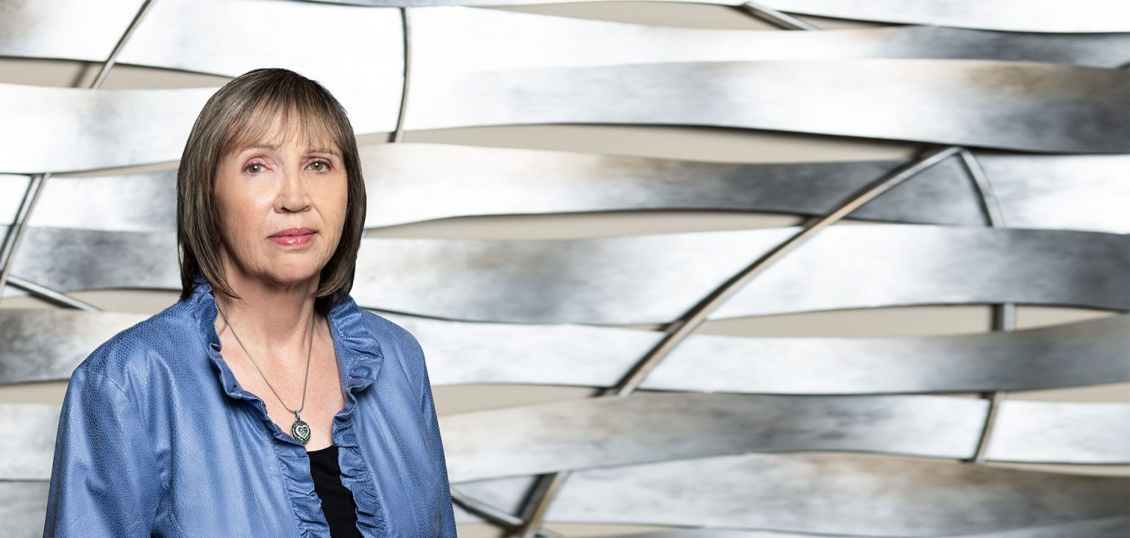

DONNA L. WELKER

Paralegal

[Business & Finance](https://www.fennemorelaw.com/services/business-and-finance/)

[Fresno](https://www.fennemorelaw.com/contact-us/fresno/)

P: 559.432.4500

F: 559.432.4590

[dwelker@fennemorelaw.com](mailto:dwelker@fennemorelaw.com)

“

Trust but verify.

-Suzanne Massie, an American writer who taught President Ronald Regan this famous Russian proverb, Doveryai

”

# DONNA L. WELKER

Donna Welker is a paralegal with our firm who provides assistance, support, advice and training in connection with estate and tax planning (including advanced drafting), trust funding, business organizations and real estate matters.

She possesses 46 years of on-the-job legal experience and continuing education courses, and was grandfathered in as a paralegal under California law. Donna likes to write and helping our clients succeed gives her great satisfaction.

Away from work, you’ll find Donna enjoying her family and friends or perhaps at Disneyland, and traveling to new destinations.

# AREAS OF PRACTICE

Business & Finance Estate Litigation Estate Planning Real Estate

# ADMISSIONS

*\*Not licensed to the practice of law*