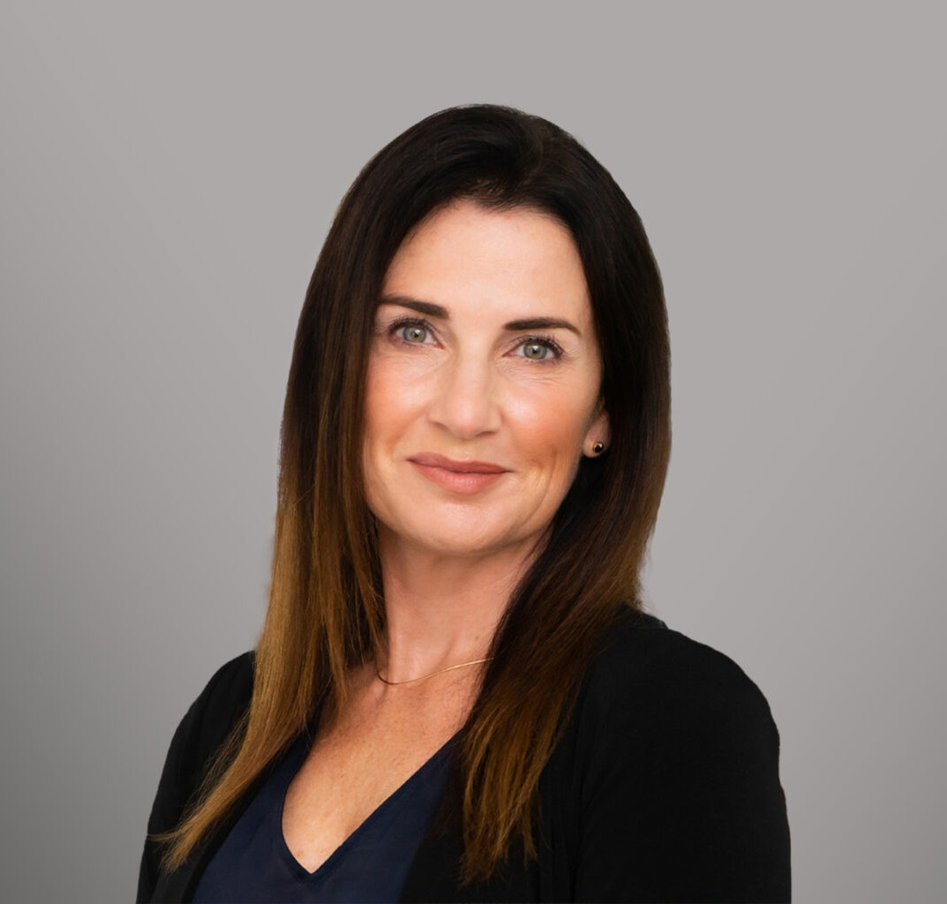

FRANCESCA K. BOYD

Director

[Trusts & Estates](https://www.fennemorelaw.com/services/trusts-estates/)

[Oakland](https://www.fennemorelaw.com/contact-us/oakland/)

P: 510.834.6600

F: 510.834.1928

[fboyd@fennemorelaw.com](mailto:fboyd@fennemorelaw.com)

# FRANCESCA K. BOYD

Francesca advises clients in all areas of estate planning, estate administrative law, wealth

management, and wealth transfer planning. She has experience in drafting complex wills and trust agreements, probating estates, administering trusts, analyzing estate and gift taxation

matters, and advising fiduciaries and beneficiaries. Representing corporate clients, Francesca has provided legal services on business formation and succession, charitable transfers and tax compliance.

Additionally, she served as Senior Project Manager of a real estate development company, overseeing design, entitlement, construction, and marketing, as well as managing outside legal counsel, financial advisors and lending institutions. In this role, she managed relationships with

investors, partners, city officials and the community. Francesca is also experienced in navigating California’s complex property tax rules governing change of ownership and reassessment of real estate.

# EDUCATION

J.D., University of San Francisco, School of Law

M.A., California Institute of Integral Studies, Psychological Studies B.A., University of St. Thomas

# AREAS OF PRACTICE

Trusts & Estates Tax Law

Estate Planning

# ARTICLES AND PRESENTATIONS

Author, “Understanding the Tax Implications of Real Property Joint Ownership Forms” CEB, Practitioner, 2023

Featuring, “Attorney Francesca Boyd on estate planning, advice for wealth transfer,” San Francisco Business Times, April 17, 2023

[Interview, “Take One Day at a Time and Trust Yourself To Make the Right Decision In The](https://www.fennemorelaw.com/take-one-day-at-a-time-and-trust-yourself-to-make-the-right-decisions-in-the-moment/) [Moment,” Fennemore Blog, September 15, 2022](https://www.fennemorelaw.com/take-one-day-at-a-time-and-trust-yourself-to-make-the-right-decisions-in-the-moment/)

Author, “Intentionally Defective Grantor Trust: Income Tax Issues,” Wendel Rosen LLP, October 21, 2021

# PROFESSIONAL AND COMMUNITY ACTIVITIES

Member, Professional Advisors Council, San Francisco Foundation Member, California Lawyer’s Association

Vice President, East Bay Trusts and Estates Lawyers, East Bay Trusts and Estates Lawyers Member, California State Bar

# ADMISSIONS

California