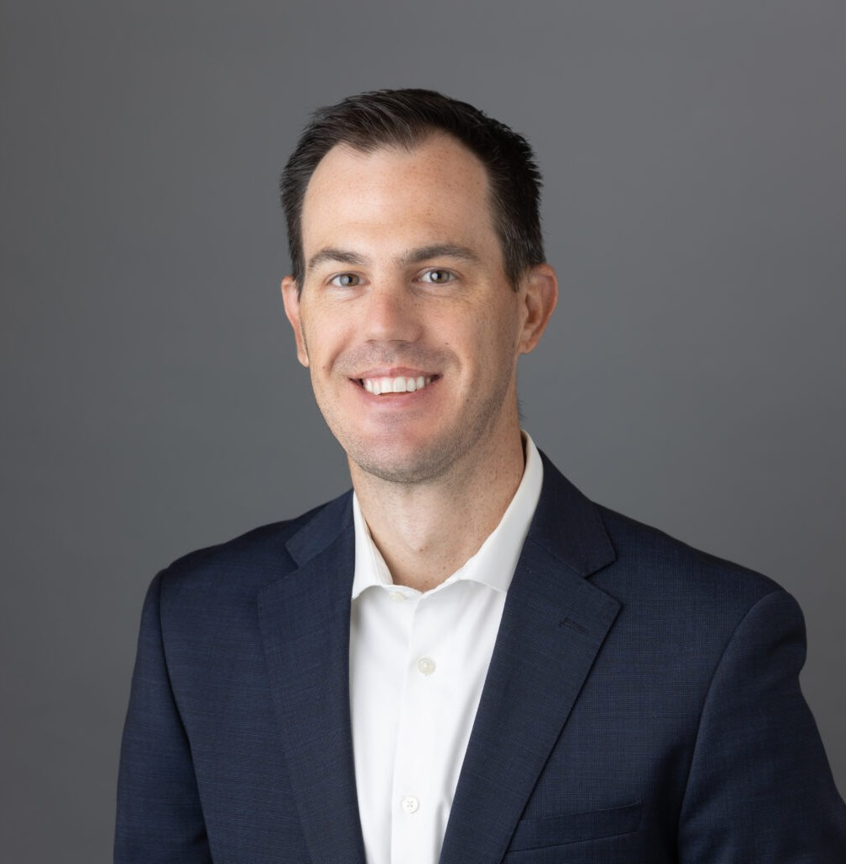

JORDAN SMITH

Paralegal

[Business Litigation](https://www.fennemorelaw.com/services/business-litigation/)

[Walnut Creek](https://www.fennemorelaw.com/contact-us/walnut-creek/)

P: 510.622.7505 F: 510.834.1928

[Oakland](https://www.fennemorelaw.com/contact-us/oakland/)

P: 510.622.7505 F: 510.834.1928

[jlsmith@fennemorelaw.com](mailto:jlsmith@fennemorelaw.com)

“

Don’t give up. Don’t ever give up.

Jim Valvano

**JORDAN SMITH**

”

Jordan Smith is a paralegal who works out of our Oakland and Walnut Creek offices, where he assists attorneys in the management of all aspects of litigation – from inception through appeals. He has extensive Trial experience throughout the entire State of California. Jordan enjoys conducting thorough investigations and document review to obtain key facts which support or dispute claims, and helping clients navigate the challenging process of litigation.

Jordan’s brothers delivered newspapers when he was younger, and filed suit on behalf of more than 1,000 newspaper carriers against the local newspaper for antitrust violations and price-

fixing, which resulted in reforming the industry. That was his first introduction to how the law

worked. He later became a summer file clerk while in school and quickly pivoted his studies to become a paralegal.

Outside of the office, Jordan is a Football Referee, currently working in the NCAA and Indoor Football League. He also worked as a high school referee throughout the state for over 10 years.

His competitive drive and strong leadership skills have aided in both his football and legal careers. Jordan also enjoys golfing, snowboarding, and anything involving the outdoors.

# EDUCATION

U.C. Berkeley Extension – Paralegal Studies, Awarded with Distinction

# AREAS OF PRACTICE

Business Litigation Estate Litigation

Employment & Labor

# PROFESSIONAL AND COMMUNITY ACTIVITIES

President, Contra Costa Football Officials Association

San Francisco-Bay Area Regional Leader, Northern California College Football Officials Organization

# ADMISSIONS

*\*Not licensed to the practice of law*