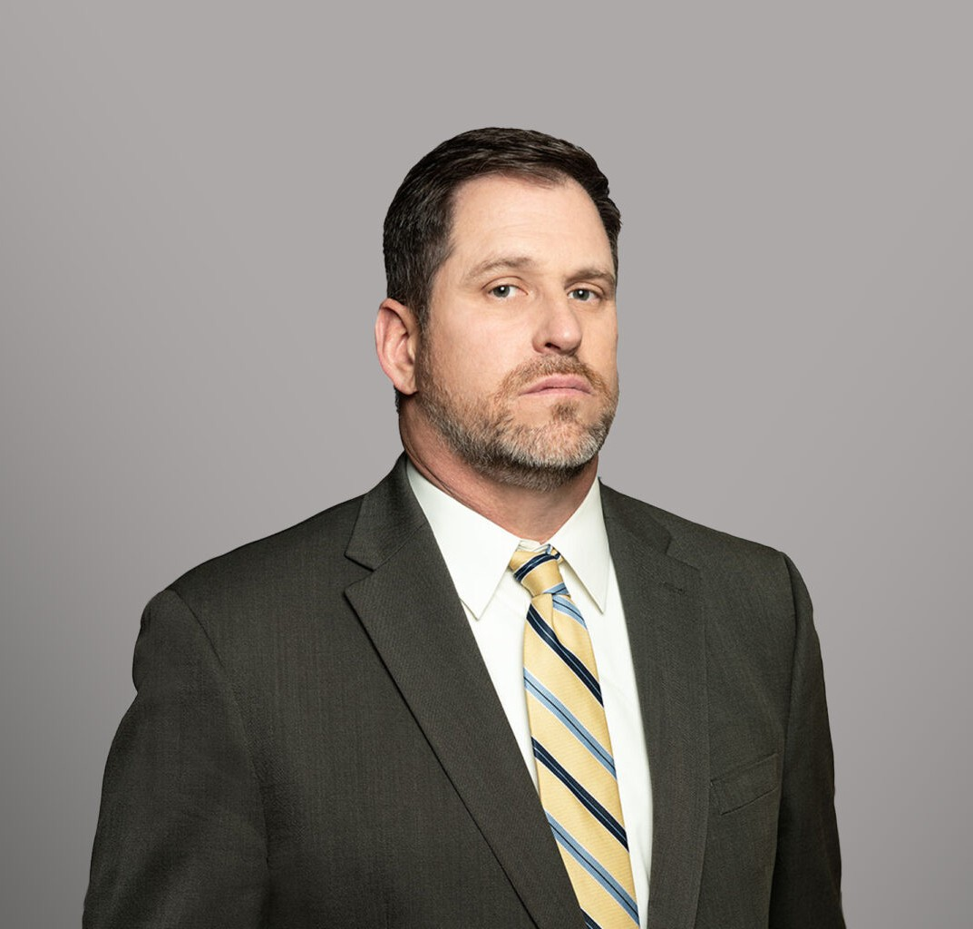

MARK D. KRUTHERS

Director

[Employment & Labor](https://www.fennemorelaw.com/services/employment-and-labor-relations/)

[Fresno](https://www.fennemorelaw.com/contact-us/fresno/)

P: 559.432.4500

F: 559.432.4590

[mkruthers@fennemorelaw.com](mailto:mkruthers@fennemorelaw.com)

**MARK D. KRUTHERS**

Mark Kruthers is an attorney in our firm’s employment law practice group. For almost three

decades, Mark has provided advice and counseling to employers and management regarding federal and state employment laws, assists in the development and implementation of legally

compliant employment policies and procedures, drafts employment related documentation (employee handbooks, employment agreements, compensation/benefit plans, disciplinary documents, etc.), conducts employee training, and assists employers with numerous other

employment related business tasks. Mark also represents employers and management in legal actions venued in both state and federal court. He handles matters before the Workers’ Compensation Appeals Board, the Department of Fair Employment and Housing, the Equal

Employment Opportunity Commission, the Division of Labor Standards Enforcement (Labor Commissioner), the Department of Labor, the California Unemployment Insurance Appeals

Board, the Occupational Safety and Health Appeals Board and various other state and federal agencies.

Clients turn to Mark because they know he can help them avoid future problems and assist them in resolving problems that already exist in an efficient and cost-effective manner. He takes great pride in his ability to help business owners/employers navigate the issues created by the numerous and complex federal and state employment laws so they can concentrate on making their businesses more successful.

# EDUCATION

J.D. Santa Clara University School of Law

B.A., Psychology University of California, Berkeley

# AREAS OF PRACTICE

Employment & Labor Business Litigation

# REPRESENTATIVE ARTICLES AND PRESENTATIONS

Presenter, “Who Is That Knocking At Your Door? – A Discussion of the Key Agencies Watching California Employers”

Author, “California’s Overtime ‘Myths’,” *The Business Journal/Law Journal – Annual Supplement*

Presenter, “California Employment Law From A to Z – Wage and Hour Pitfalls for the Unwary”

Presenter, “Employment Law For The Business Attorney,” Fresno County Bar Association Business Law Section

Quoted, “Did You Fire for Cause or Out of Retaliation?” Workest, May 16, 2022 [Interview, “Prepare to Be Flexible,” Fennemore Blog, June 24, 2021](https://www.fennemorelaw.com/insights/blogs/2021/prepare-to-be-flexible)

Quoted, “Can Small Businesses Require COVID Vaccines in the Workplace?” Workest, May 21, 2021

Quoted, “New CDC Guidelines Pose Complications for Office Space,” Globest.com, May 19, 2021

Quoted, “Covid Creates New HR And Legal Challenges For Employers,” *Forbes,* May 11, 2021

Quoted, “Face mask detection a newcomer to employee surveillance,” *TechTarget*, April 19, 2021

Quoted, “With no federal COVID-19 liability shield, states go to it alone,” *TechTarget,*

December 21, 2020

Quoted, “What does California’s Prop 22 mean for the gig economy?” *The Millennial Source*, November 8, 2020

Presenter, “California Employment Law From A to Z – Wage and Hour Pitfalls for the Unwary”

Presenter, “Employment Law For The Business Attorney,” Fresno County Bar Association Business Law Section

Presenter, “Employee Lawsuits in 2020: Some of the Major Problems Employers Will Face Under California Law”

Presenter, “Who Is That Knocking At Your Door? – A Discussion of the Key Agencies Watching California Employers”

Author, “The Dynamex Test: A Never-Ending Nightmare for California Businesses”

Author, “California’s Overtime ‘Myths’,” *The Business Journal/Law Journal – Annual Supplement*

# PROFESSIONAL AND COMMUNITY ACTIVITIES

Member, Fresno County Bar Association Member, State Bar of California

Member, State Bar of California Labor and Employment Law and Litigation Sections

# ADMISSIONS

California

U.S. District Court Central District of California

U.S. District Court Eastern District of California