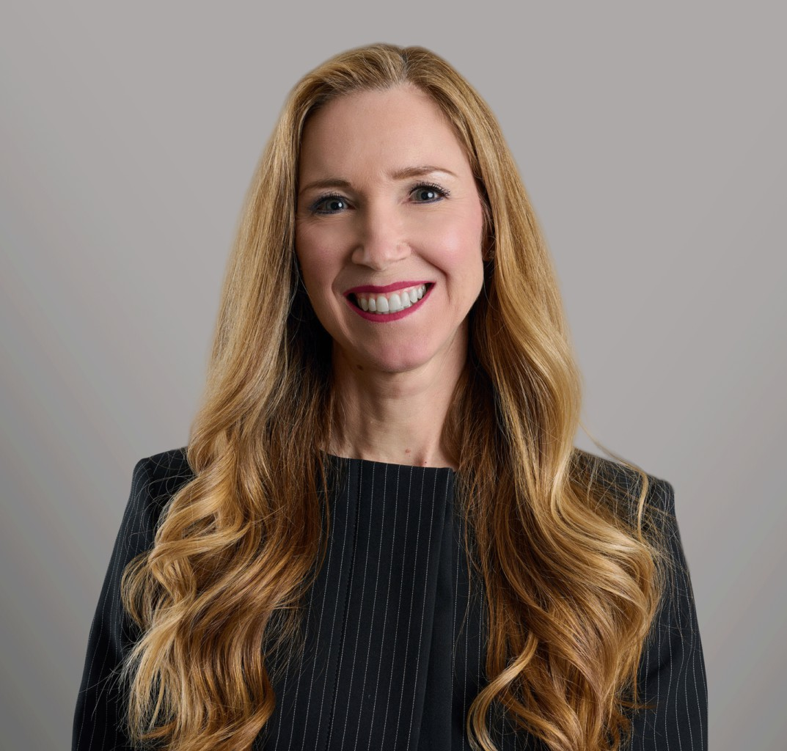

MICHELE L. STEPHEN

Director

[Business Litigation](https://www.fennemorelaw.com/services/business-litigation/)

[Seattle](https://www.fennemorelaw.com/contact-us/seattle/)

P: 206.749.0500

F: 206.749.0600

[mstephen@fennemorelaw.com](mailto:mstephen@fennemorelaw.com)

# MICHELE L. STEPHEN

Michele has extensive complex commercial litigation experience representing corporate and entrepreneurial clients in state and federal courts in disputes involving intellectual property, commercial and partnership contracts, business torts, and other complex matters. Michele earns client loyalty through informed, tenacious representation, balanced and driven by business

needs. Her ability to develop and marshal a multitude of facts in a strategic and cohesive way leads to successful results for her clients, whether achieved at trial or in a favorable settlement. Michele also counsels clients on pre-litigation planning and strategy and litigation avoidance.

Before joining Fennemore, Michele was a partner in Savitt Bruce & Willey LLP and, before that, a partner at Freeborn & Peters in Chicago. Michele is a graduate of Loyola University Chicago School of Law.

Michele was born and raised in sunny San Diego, which she willingly left to attend law school in Chicago and experience true winter. After buying her first winter coat, she spent almost eleven years there before coming to Seattle in 2007 with her husband. They and their son enjoy continued exploration of all the Pacific Northwest has to offer.

# EDUCATION

J.D., Loyola University of Chicago School of Law B.A., San Diego State University

# AREAS OF PRACTICE

Business Litigation Intellectual Property

# REPRESENTATIVE MATTERS

***Nippon Dynawave Packaging Co. v. North Pacific Paper Company.*** Prosecuted claims and defended counterclaims arising from site services agreement for interconnected industrial facilities; obtained favorable settlement.

***Move, Inc., et al. v. Zillow, Inc., et al.*** Represented executive defending against trade secret and employment claims in lawsuit seeking $2 billion in damages and career-ending relief; obtained summary judgment on purported trade secret document, defended at evidentiary hearing spoliation allegations, and obtained favorable settlement prior to trial.

***InfoFlows v. Corbis.*** Prosecuted claims for misappropriation of trade secrets, fraud and breach of contract relating to digital image tracking technology, and defended related

counterclaims; obtained $36 million jury verdict and defeated counterclaims in three-week trial.

***Superwood Co. Ltd. v. Slam Brands, Inc., et al.*** Engaged at close of discovery to replace prior counsel and represent Defendants regarding breach of contract claims and counterclaims under the UCC, as well as related tort claims and counterclaims concerning the manufacture of furniture in China by Plaintiff; established significant off-set amounts due to our client on a successful motion for partial summary judgment, and defeated Plaintiff’s motion for partial summary judgment; following a bench trial, which included an additional award of contract damages to our client, the matter was favorably resolved by a confidential settlement.

***Optistor Technologies v. Nutanix et al.*** Defended cloud software and infrastructure-solution provider and its employee against claims for breach of contract, trade secret

misappropriation, and tortious interference; obtained summary judgment ruling, including voiding of employee non-compete, and then favorable settlement.

***ChemPoint v. Xenon Arc Inc., et al.*** Defended technology startup and its founders against claims for misappropriation of trade secrets, false advertising, usurpation of corporate opportunity and breach of fiduciary duty; obtained ruling entitling clients to advancement of fees under plaintiff’s articles of incorporation, partial summary judgment, and then favorable settlement.

***Taylor, et al. v. City of Seattle, City Light.*** Engaged during discovery to serve as co-counsel with Seattle City Attorney’s Office defending City against two former and one current

employees’ claims under Washington Law Against Discrimination for age, gender, and sexual orientation discrimination, retaliation, and hostile work environment; while defendant’s motions for summary judgment were pending, case settled on confidential terms.

***Estates of Diaz, et al. v. City and Borough of Sitka, et al.*** Defended City and Borough of Sitka against claims relating to fatal landslide and engineered favorable settlement after substantial discovery and other pretrial practice.

***Alliance Packaging v. Altivity Packaging, et al.*** Prosecuted patent infringement claims relating to retail product packaging; prevailed at Markman hearing, defeated defendant’s summary judgment motions and prevailed on motions for partial summary judgment and motions dismissing counterclaims, and then obtained favorable settlement.

***Seelig v. Seelig.*** Defended claims and prosecuted counterclaims involving allocation of assets and profits from long-term real estate partnerships; obtained summary judgment prevailing on all claims relating to division of assets and profits, and then negotiated settlement to wind up partnerships and distribute monies accordingly to end litigation.

***Montano v. City of Seattle.*** Defended tort and inverse condemnation claims brought by multiple property owners alleging damage resulting from City’s management of surface water and storm response.

# AWARDS AND HONORS

Best Lawyers in America, 2024 and 2025

Washington Super Lawyers, 2017-2024

Washington Super Lawyers Top Women Lawyers in Washington, 2023

# ARTICLES AND PRESENTATIONS

Co-Author, “[Provisional Remedies: Washington, Practical Law,](http://us.practicallaw.com/w-000-6380)” Thomson Reuters, August 2023

Presenter, Covering Your Bases: Practical Tips to Deal with and Avoid Litigation, Washington Association of Corporate Counsel, 2013

# PROFESSIONAL AND COMMUNITY ACTIVITIES

Member, Federal Bar Association of the Western District of Washington Member, American Bar Association

Member, Washington State Bar Association

# ADMISSIONS

Washington California

United States District Court, Western District of Washington United States District Court, Northern District of Illinois United States District Court, Northern District of California United States District Court, Eastern District of California