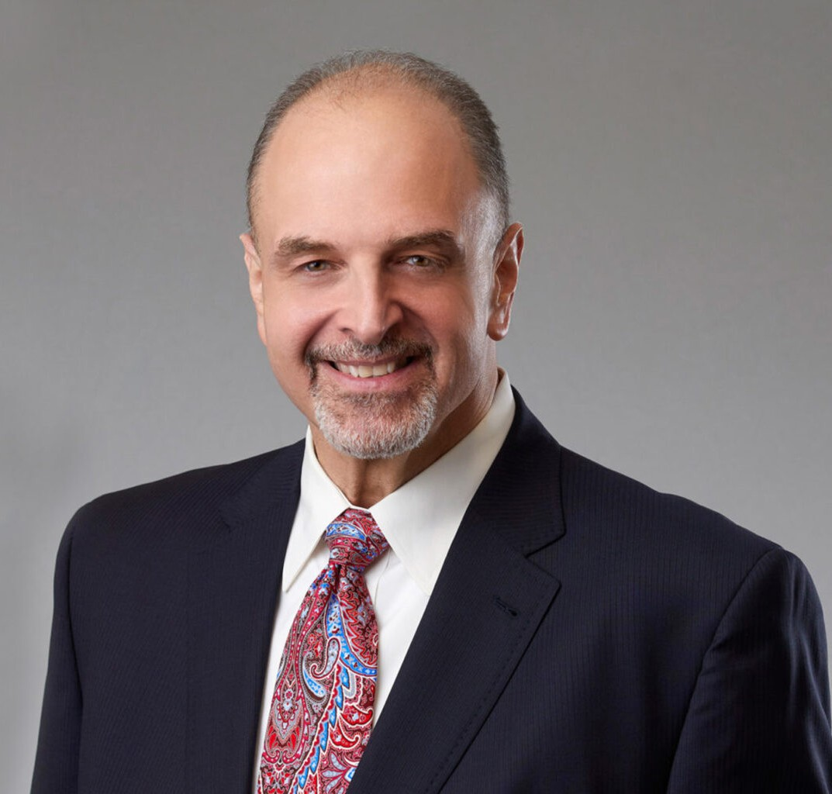

RICHARD DREITZER

Director

[Business Litigation](https://www.fennemorelaw.com/services/business-litigation/)

[Las Vegas](https://www.fennemorelaw.com/contact-us/las-vegas/)

P: 702.692.8026

F: 702.692.8075

[rdreitzer@fennemorelaw.com](mailto:rdreitzer@fennemorelaw.com)

**RICHARD DREITZER**

Richard Dreitzer serves on Fennemore’s eight-person management committee and is the managing partner of our Las Vegas office. He works in the business litigation practice group, where he focuses primarily in the areas of labor and employment law, administrative law, and general commercial litigation, including construction. With more than two decades of experience as a business litigator, he has guided a broad range of clients through traditional labor matters such as Title VII defense, ERISA claims, wage and hour disputes, OSHA

proceedings, collective bargaining, and representation of employers before the National Labor Relations Board.

In the construction and real estate litigation arena, Richard represents clients in construction law matters, serving as lead counsel on behalf of general contractors, subcontractors and materials suppliers in litigation involving public and private projects in both state and federal courts.

In the administrative law space, Richard was formerly a deputy attorney general in Nevada, where he served as Board Counsel and Prosecutor for a variety of State of Nevada Boards and Commissions. Since leaving government service, Richard has continued his representation of state agencies in a private capacity, prosecuting regulatory infractions by professional licensees, and serving as Board Counsel and Prosecutor during hearings and in appellate proceedings before the Nevada District Courts and the Nevada Supreme Court.

Beginning in 1996 with a clerkship in Las Vegas, today Richard is a fixture in the Nevada legal community, and he thoroughly enjoys the mental challenges of working at a large law firm on

complex litigation matters with a dynamic team of business litigation attorneys. He views his work like looking at a puzzle — seeking new approaches to solving problems, which may be unseen

at first glance.

Rich is presently in his fifth term as a member of the Board of Governors of the State Bar of

Nevada (having served since 2013), and was recently elected Vice President of the State Bar of Nevada. Rich also serves as Chairman of the Board of Directors of Nevada Public Radio and was recently chosen to serve on the Advisory Council for The Mob Museum in downtown Las Vegas.

# EDUCATION

J.D., Washington University School of Law

B.S., College of Industrial and Labor Relations, Cornell University

# AREAS OF PRACTICE

**OTHER EXPERIENCE**

Insurance Regulatory and Compliance Life, Health and Disability

Manage Care Litigation and Compliance Business Litigation

Construction Law

Employment & Labor ERISA

Real Estate

# AWARDS AND HONORS

*Best Lawyers in America®,* Commercial Litigation/Employment Law – Individuals/Employment Law—Management/Litigation –Construction/ Litigation– Labor & Employment, 2019-2025

“Legal Elite,” *Nevada Business Magazine*, 2020-2021

“Rookie of the Year,” State of Nevada Office of the Attorney General, 2005

AV® Preeminent™ Peer Review Rated (the highest rating available), by Martindale-Hubbell

# ARTICLES AND PRESENTATIONS

Featuring, “ON THE MOVE: Wells Fargo announces promotion,” Las Vegas Business Press, July 10, 2023

Featuring, “People on the Move: July 10, 2023,” Las Vegas Sun, July 10, 2023

Featuring, “Nevada Business: Industry Focus,” Nevada Business, December 2, 2022 Featuring, “Mandatory overtime: What you need to know,” Clockify, April 7, 2023

[Interview, “It is only in the presence of humility that learning and professional growth becomes](https://www.fennemorelaw.com/it-is-only-in-the-presence-of-humility-that-learning-and-professional-growth-becomes-possible/) [possible,” Fennemore Blog, October 7, 2021](https://www.fennemorelaw.com/it-is-only-in-the-presence-of-humility-that-learning-and-professional-growth-becomes-possible/)

Interview, “Labor, employment specialist discusses President Biden’s vaccine mandates,” KTNV Las Vegas, September 9, 2021

Interview, “Can employees who refuse the COVID-19 vaccine get unemployment benefits?” KTNV Las Vegas, September 8, 2021

Quoted, “Las Vegas small business owner leaves mask decision to customers,” KTNV Las Vegas, May 14, 2021

Quoted, “Mask guidance relaxed for vaccinated individuals, employers can impose their own mask requirements,” KTNV Las Vegas, May 13, 2021

Quoted, “BACK TO WORK: Can remote employees be forced back to work in-person?” KTNV Las Vegas, May 3, 2021

Quoted, “Get vaccine or submit to weekly test: Wynn Las Vegas employee fumes over options,” KTVN Las Vegas, April 8, 2021

[Podcast, “Fenn.Talks: Reaching New Heights with Richard Dreitzer,” April 7, 2021](https://www.youtube.com/watch?v=tifuvxyUv7M)

Quoted, “COVID-19 Vaccine and Employers,” KTNV Las Vegas, December 8, 2020 Quoted, “COVID-19 Vaccine and Employers,” KVVU Fox 5, December 7, 2020

Quoted, “Insurer fires back against Durham business owners’ Covid claims,” *Triangle Business Journal,* September 30, 2020

Speaker, “Pandemic Paradigm Shift: The Perils and the Promise,” State Bar of Nevada Webinar, June 30, 2020

Quoted, “As Georgia Reopens Nail and Hair Salons, Lawyers Say Companies May be Putting Themselves at Risk,” *Yahoo Life,* April 24, 2020

Quoted, “How to Keep Your Employees Healthy During the Coronavirus,” *Business.com*, April 7, 2020

Interview, “Small business loans: How and when to apply,” Fox 11, April 7, 2020 Interview, “Assistance for Small Businesses,” Fox 11, April 7, 2020

[Co-author, “COVID-19: Health Plan Coverage For Furloughed Employees,” Fennemore Client](https://www.fennemorelaw.com/insights/newsletters/2020/covid-19-health-plan-coverage-for-furloughed-employees) [Alert, March 26, 2020](https://www.fennemorelaw.com/insights/newsletters/2020/covid-19-health-plan-coverage-for-furloughed-employees)

[Co-author, “Understanding the Emergency Family Medical Leave Expansion Act and](https://www.fennemorelaw.com/insights/newsletters/2020/understanding-the-emergency-family-medical-leave-expansion-act-and-emergency-paid-sick-leave-in-the-families-first-coronavirus-response-act) [Emergency Paid Sick Leave in the Families First Coronavirus Response Act,” Fennemore Client](https://www.fennemorelaw.com/insights/newsletters/2020/understanding-the-emergency-family-medical-leave-expansion-act-and-emergency-paid-sick-leave-in-the-families-first-coronavirus-response-act) [Alert, March 20, 2020](https://www.fennemorelaw.com/insights/newsletters/2020/understanding-the-emergency-family-medical-leave-expansion-act-and-emergency-paid-sick-leave-in-the-families-first-coronavirus-response-act)

[Interview, “Coronavirus Relief Bill,” Fox 5 News Las Vegas, March 19, 2020](https://muckrack.com/broadcast/savedclips/view/eObGWekWNa)

Quoted, “Q + A: Las Vegas Lawyer Talks About Labor Law as Coronavirus Alters Workplace,”

*Las Vegas Sun,* March 17, 2020

[Co-author, “Frequently Asked Questions About the Coronavirus in the Employment Setting,”](https://www.fennemorelaw.com/insights/newsletters/2020/frequently-asked-questions-about-the-coronavirus-in-the-employment-setting) [Fennemore Client Alert, March 17, 2020](https://www.fennemorelaw.com/insights/newsletters/2020/frequently-asked-questions-about-the-coronavirus-in-the-employment-setting)

Interview, “MGM Resorts report layoffs: Local attorney explains workers’ rights,” KTNV News, March 14, 2020

Quoted, “New Trade Deal Provisions Give US Tech Firms Legal Shields,” *eCommerce Times,*

October 9, 2019

# PROFESSIONAL AND COMMUNITY ACTIVITIES

President, State Bar of Nevada, 2024-2025

Vice President, Board of Governors, State Bar of Nevada, 2022-present Member, Advisory Council, The Mob Museum, 2022-present

Chairman of the Board of Directors, Nevada Public Radio, 2021-present Vice Chair, Nevada Public Radio, 2019-2021

Member, Board of Governors, State Bar of Nevada, 2013-present Board Member, Nevada Public Radio, 2013-present

Member, Fee Dispute Committee, State Bar of Nevada, 2011-present

Member, Lawyers Referral Information Service Committee, State Bar of Nevada, 2011-2014

Member, Ethics and Professional Responsibility Committee, State Bar of Nevada, 2001-2004 Member, State of Nevada Board of Continuing Legal Education, 2014-2021

Justice of the Peace, Pro Tempore, Justice Court, Las Vegas Township, 2009-2018 Small Claims Court Referee, Justice Court, Las Vegas Township, 2009-2020

# ADMISSIONS

Arizona Missouri Nevada

U.S. District Court, Northern District of California

U.S. District Court, District of Nevada

U.S. Court of Appeals, Fifth Circuit

U.S. Court of Appeals, Ninth Circuit

U.S. Bankruptcy Court, District of Nevada