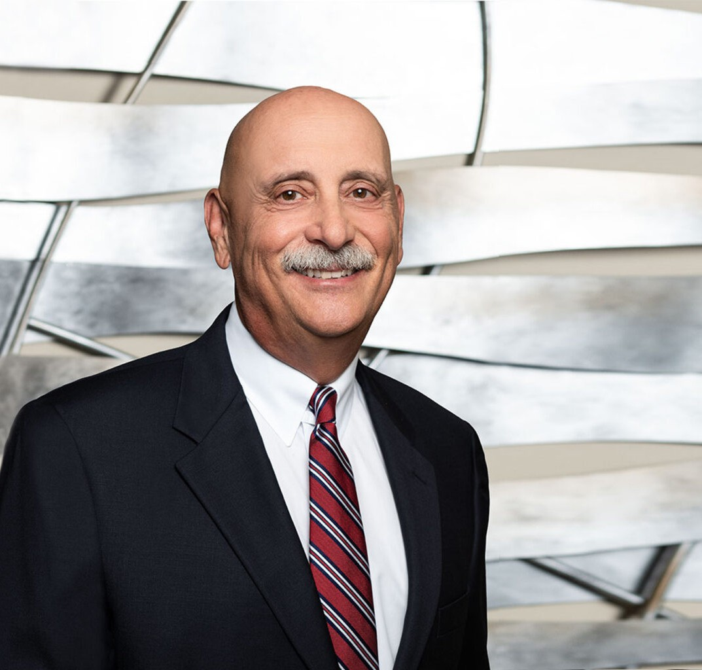

RICHARD M. AARON

California Region Chair

[Trusts & Estates](https://www.fennemorelaw.com/services/trusts-estates/)

[Fresno](https://www.fennemorelaw.com/contact-us/fresno/)

P: 559.432.4500

F: 559.432.4590

[raaron@fennemorelaw.com](mailto:raaron@fennemorelaw.com)

“

What's right about America is that although we have a mess of problems, we have great capacity - intellect and resources - to do something about them.

-Henry Ford

”

**AARON, RICHARD M.**

Richard Aaron has a diverse business transactions, corporate, and real estate practice, which dovetails with an active succession and estate planning practice. Since 1979, he has devoted his entire legal career to our firm, serving clients and providing firm leadership, and currently serves as the firm’s California Region Chair.

He also acts as general counsel to many companies involved in a wide variety of industries and service groups, including automobile dealerships, farming, food processing, packing houses,

marketing, manufacturing, commercial and residential real estate development, healthcare and professional practices (forming and representing numerous medical groups throughout California). In addition to counseling mature businesses, Richard has guided a number of start-up companies through formation, fund-raising, development into operating companies, and execution of exit strategies.

Richard earned his undergraduate degree in finance at the USC School of Business and honed his business skills by selling cars, even while attending UC Hastings College of the Law –one of the top-rated law schools in the United States. In fact, Richard became so good at it that he became a sales manager for a very large Bay Area Ford dealership. While still attending

Hastings, he was offered to participate in the Ford Motor Company’s Dealer Development

program, which gave him the opportunity to have his own dealership. He cleverly turned it down (twice)to make less money and work longer hours as an attorney!

Richard is certified by the California Board of Legal Specialization of the State Bar of California as a Specialist in Probate, Estate Planning and Trust Law. His unique breadth of experience allows him to counsel business, corporate, professional and estate planning clients with a perspective

that cohesively integrates a number of specialties in a way that offers clients cost-effective, practical solutions to their problems.

Happily married to his wife, Nancy, for over 48 years, four wonderful kids and three fully spoiled grandchildren and one grand dog later, Richard makes his family his main priority and blows off steam by playing a regular round of golf with some 20 buddies of all ages and walks of life. He also loves fast cars!

In addition to managing a very busy practice, Richard makes an impact in the community, serving on the boards of a number of for-profit and non-profit entities, and has been a frequent speaker and lecturer to professional, civic, and trade associations (Including California Continuing Education of the Bar, California CPA Society Education Foundation, and California State University Fresno).

# EDUCATION

J.D., University of California, Hastings College of Law

B.A., Business Administration/Finance, University of Southern California Beta Gamma Sigma

# AREAS OF PRACTICE

**OTHER EXPERIENCE**

Administration and Probate Private Equity and Securities Trusts & Estates

Business & Finance Agribusiness

Mergers & Acquisitions Tax Law

Real Estate Estate Planning

# AWARDS AND HONORS

*Super Lawyers®*

AV® Preeminent™ Peer Review Rated (the highest rating available), by Martindale-Hubbell

# ARTICLES AND PRESENTATIONS

Featuring, “Illegal racist covenants linger in Fresno County property records. ‘It’s a disgrace’,” Fresno Bee, March 6, 2023

Interview, “Executive Profile: Richard Aaron,” *The Business Journal,* September 25, 2020

Interview, “Make Sure Every Year Has Been Sweeter Than the Last,” *Attorney at Law Magazine*, September 24, 2020

# PROFESSIONAL AND COMMUNITY ACTIVITIES

Member, Fresno Estate Planning Council

Member, Fresno County Bar Association, Estate Planning, Income Tax and Probate Sections Member, State Bar of California, Business Law Section

Member, American Bar Association, Business and Health Care Law Sections

# ADMISSIONS

California

U.S. District Court, Eastern District of California