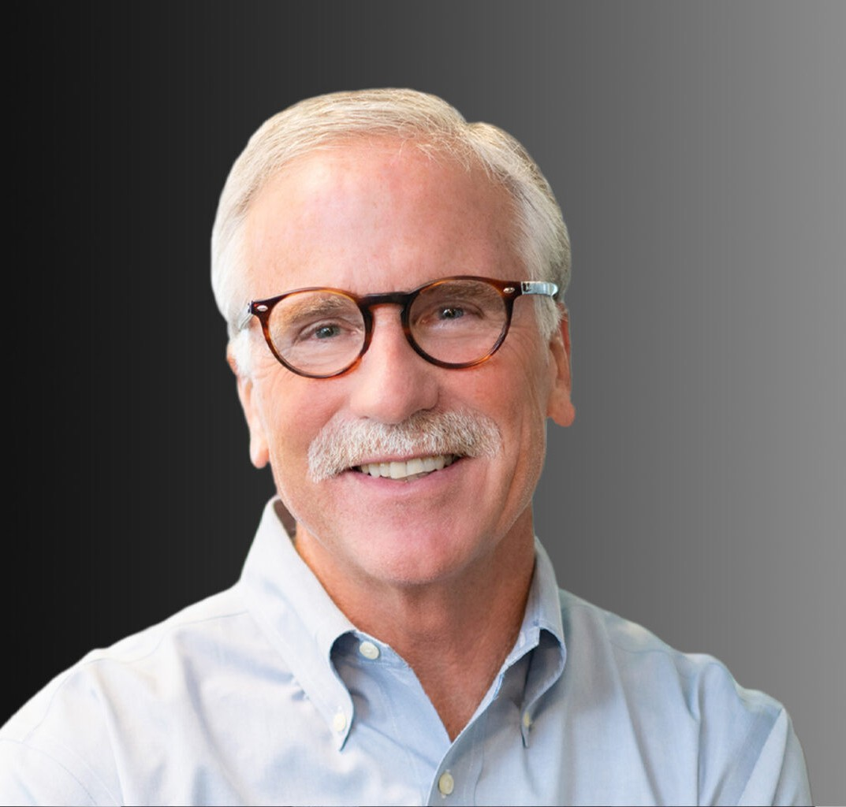

STEVEN J. CRAMER

Director

[Business & Finance](https://www.fennemorelaw.com/services/business-and-finance/)

[Oakland](https://www.fennemorelaw.com/contact-us/oakland/)

P: 510.834.6600

F: 510.834.1928

[scramer@fennemorelaw.com](mailto:scramer@fennemorelaw.com)

# STEVEN J. CRAMER

Steve Cramer has practiced law for over 30 years. Steve focuses on commercial and real estate transactions, representing both buyers and sellers in public and private merger and acquisitions. He also works with clients, from international corporations to smaller, regional enterprises, in an array of business transactional matters, including entity formation and charter documents. Steve also provides counsel to clients and other attorneys on business regulatory matters, including applications of corporate, securities, tax and lender laws.

# EDUCATION

J.D., University of California, Los Angeles School of Law B.A., University of Santa Clara

# AREAS OF PRACTICE

OTHER EXPERIENCE

Nonprofits and Trade Organizations Business & Finance

Real Estate

Mergers & Acquisitions

# REPRESENTATIVE CASES

Represented acquiring company in significant merger between engineering firms serving the California energy sector. This business combination involved complex regulatory compliance and logistical issues.

Represented purchasers in $100 million retail chain acquisition involving complex regulatory compliance and tax issues.

Represented franchisor in petroleum industry acquisition involving in excess of 120 franchised sites.

Mergers and acquisitions

# ARTICLES AND PRESENTATIONS

[Interview, “Lessons Learned & Reflections On Life In The Law With Steve Cramer,” Fennemore](https://www.fennemorelaw.com/if-you-find-that-every-attorney-on-the-other-side-of-a-matter-is-a-jerk-you-might-want-to-re-think-your-style/) [Blog, August 18, 2022](https://www.fennemorelaw.com/if-you-find-that-every-attorney-on-the-other-side-of-a-matter-is-a-jerk-you-might-want-to-re-think-your-style/)

# PROFESSIONAL AND COMMUNITY ACTIVITIES

Member, Alameda County Bar Association

Former Director, Board of Secretary, East Bay Manufacturing Group

# ADMISSIONS

California

U.S. District Courts, Central District of California

U.S. District Courts, Northern District of California