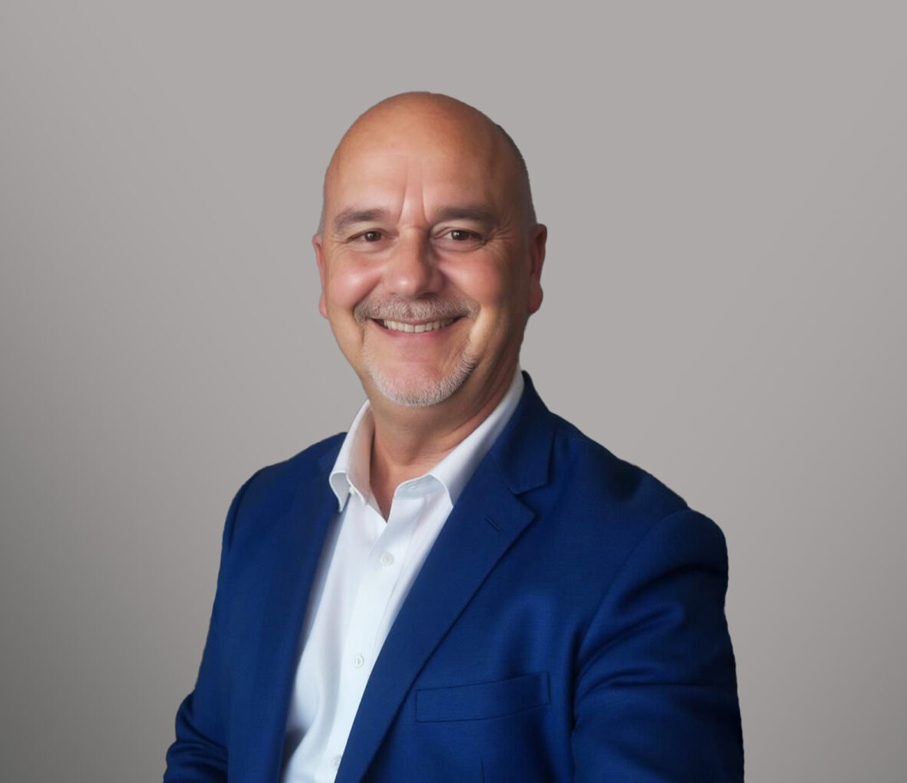

TIM KNEIS

Paralegal

[Trusts & Estates](https://www.fennemorelaw.com/services/trusts-estates/)

[Oakland](https://www.fennemorelaw.com/contact-us/oakland/)

P: 510.834.6600 F: 510.834.6600

[tkneis@fennemorelaw.com](mailto:tkneis@fennemorelaw.com)

**TIM KNEIS**“

Keep passing the open windows

”

Tim Kneis is a paralegal who works out of our Oakland office where his work focuses on several probate and post-death trust administrations.

Originally. Tim was working as a Trust Officer at a bank and a law firm he worked with closely was looking for a probate paralegal, and he thought it would be a nice and challenging change. In his role at our firm, Tim takes great pride in knowing that the services we provide the clients is tremendously helpful during what can be a difficult time following the death of a loved one.

Outside of work, Tim unwinds by reading and playing golf.

Trusts & Estates

# EDUCATION

B.A., San Francisco State University

# AREAS OF PRACTICE

Trusts & Estates

# PROFESSIONAL AND COMMUNITY AFFILIATIONS

Member, San Francisco Bar Association

# ARTICLES AND PRESENTATIONS

Speaker, “The Probate Process from Start to Finish in California,” National Business Institute Speaker, “How to Avoid Being Haunted by Probate Pitfalls,” Daily Journal Corporation

Speaker, “Conservatorship and Guardianship Accountings, Keeping Tabs and How to Read Between the Lines of an Accounting,” California Association of Superior Court Investigators

Speaker, “Recent Developments and Current Topics in the San Francisco Probate Court,” Estate Planning, Trust & Probate Section of the San Francisco Bar Association

Presenter, “And the estate is in a position to be closed – Petitions for Final Distribution in California Probate Estates,” Continuing Education of the Bar

# ADMISSIONS

*\*Not licensed to the practice of law*