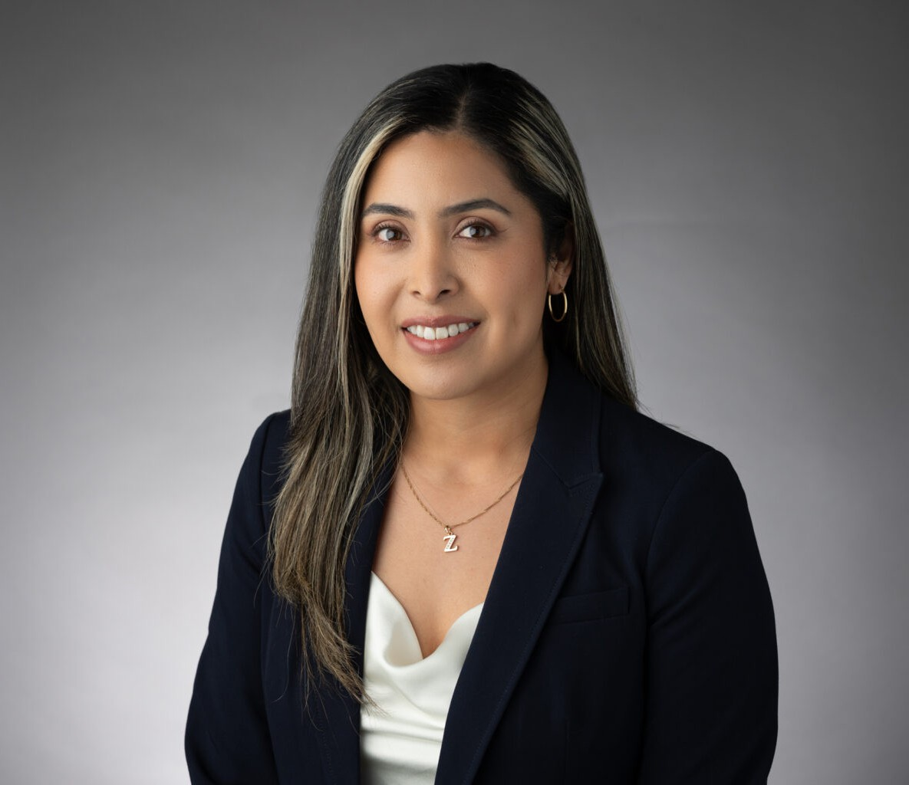

ZURY MOLINA

Associate

[Business Litigation](https://www.fennemorelaw.com/services/business-litigation/)

[Oakland](https://www.fennemorelaw.com/contact-us/oakland/)

P: 510.622.7528 F: 510.622.7571

[zmolina@fennemorelaw.com](mailto:zmolina@fennemorelaw.com)

# ZURY MOLINA

Zury Molina is an Associate Attorney at the firm practicing [business litigation](https://www.fennemorelaw.com/services/business-litigation/). Her practice encompasses diverse litigation matters, including labor and employment, breach of contract, real estate, commercial disputes, fraud, and negligence.

Zury earned her law degree from the University of California College of the Law, San Francisco. During law school, she was a staff editor and senior acquisitions editor at the UC Law Environmental Journal and a semi-finalist in the Hispanic National Bar Association Moot Court

Competition. She also served as a teaching assistant for Constitutional Law I and Legal Research and Writing, deepening her expertise in legal doctrine.

Before attending law school Zury was a high school teacher where her passion for learning and advocacy led her to a career in law. Her teaching experience sharpened her ability to clarify complex concepts—an asset she now applies to intricate legal issues. Zury is committed to

delivering practical, client-focused solutions, combining her analytical expertise with a steadfast dedication to protecting her clients’ interests.

Outside of work, Zury enjoys strength training, fashion, spending time with her family, and exploring museums around the world.

Business Litigation

# EDUCATION

J.D., University of California College of the Law, San Francisco M.A., Loyola Marymount University

B.A., University of California, Berkeley

# AREAS OF PRACTICE

Business Litigation

# PROFESSIONAL AND COMMUNITY ACTIVITIES

Board Member, San Francisco La Raza Lawyers Association

Board Member, Oakland Public Education Fund Advisory Board

# AWARDS AND HONORS

Semi-Finalist Award, Hispanic National Bar Association Moot Court Competition Best Oral Argument, Legal Research and Writing 2

# ADMISSIONS

California

# LANGUAGE

Spanish

Italian (Conversational)