Helping Agribusiness Thrive Locally, Nationally and Internationally

Our experienced agricultural attorneys provide a broad range of assistance to clients, both domestically and internationally, in many areas of agribusiness and agricultural law.

With offices in Arizona, California, and Texas, we serve clients operating in the largest food producing region in the United States and one of the largest food producing regions in the world and in primary ports of entry for importing and exporting fresh fruits and vegetables between the United States and Mexico.

**LEADERSHIP**

[AGRIBUSINESS](https://www.fennemorelaw.com/services/agribusiness/)

[TRUSTS & ESTATES](https://www.fennemorelaw.com/services/trusts-estates/)

[**Richard M.**](https://www.fennemorelaw.com/people/attorneys/richard-m-aaron/)[**Aaron**](https://www.fennemorelaw.com/people/attorneys/richard-m-aaron/)

California Region Chair

[**Fresno**](https://www.fennemorelaw.com/contact-us/#fresno)

PH 559.432.4500

FX 559.432.4590

[raaron@fennemorela](mailto:raaron@fennemorelaw.com) [w.com](mailto:raaron@fennemorelaw.com)

[AGRIBUSINESS](https://www.fennemorelaw.com/services/agribusiness/)

[BUSINESS &](https://www.fennemorelaw.com/services/business-and-finance/) [FINANCE](https://www.fennemorelaw.com/services/business-and-finance/)

[**Kimberly A.**](https://www.fennemorelaw.com/people/attorneys/kimberly-a-arana/)[**Arana**](https://www.fennemorelaw.com/people/attorneys/kimberly-a-arana/)

Director

[**Nogales**](https://www.fennemorelaw.com/contact-us/#nogales)

PH 520.281.3481

FX 520.281.3495

[karana@fennemorela](mailto:karana@fennemorelaw.com) [w.com](mailto:karana@fennemorelaw.com)

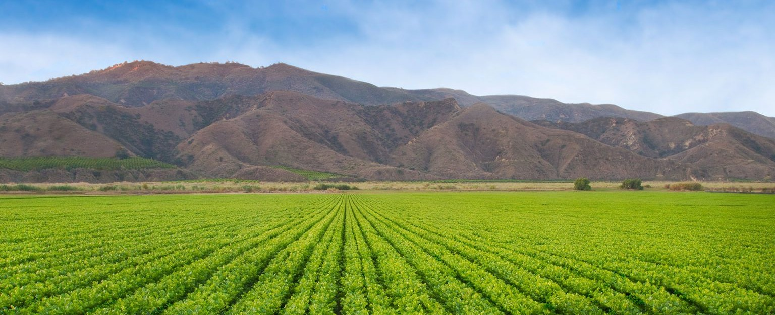

# WHAT WE DO

Our Agribusiness team is one of the most robust legal groups in the West! Our attorneys have a tremendous track record of assisting clients in every role within the produce industry by providing practical experience, knowledge, and legal expertise that is unique to agribusiness. We

represent farmers, growers, packers, shippers, distributors, importers, exporters, processors,

dairies, wineries, cooperatives, investors, lenders, insurance providers and others involved in the food production industry with local, national, and international operations.

We have offices throughout California, including in the Central Valley, the largest food producing region in the United States, and in Nogales, Arizona and McAllen, Texas, primary ports for import and export of fresh fruits and vegetables between the United States and Mexico. We have decades of experience in all aspects of agribusiness and agricultural law. Fennemore’s agribusiness attorneys are uniquely positioned to assist clients in the agricultural community.

## [BUSINESS AND FINANCE](https://www.fennemorelaw.com/services/practices/business-and-finance)

Our agribusiness attorneys have a diverse range of expertise in representing local, national and international clients participating in significant business transactions, including negotiating and drafting distributor and grower, consignment, sales, import, export and related agreements, representing clients with regard to agribusiness financing arrangements, including cross-border financing. Our attorneys are able to assist in every aspect of a business, from entity formations and maintenance, to business structures including international structures, to mergers and

acquisitions.

## [INTELLECTUAL PROPERTY](https://www.fennemorelaw.com/services/practices/intellectual-property-and-ip-litigation)

Our intellectual property attorneys have decades of experience in assisting agribusiness companies protect their valuable intellectual property, including patents, trade secrets,

trademarks, copyrights, and other labeling and marketing issues. We assist clients with licensing in order to help protect them and to leverage and protect their valuable intellectual property. Our intellectual property attorneys have considerable experience enforcing intellectual property rights and in resolving intellectual property disputes.

## [ESTATE PLANNING](https://www.fennemorelaw.com/services/practices/estate-planning)

We know that for many in the agricultural community, farming is a family affair with businesses being passed down from generation to generation. With estate and business planning departments experienced in the unique aspects of business and succession strategies within the agricultural industry, we are able to help clients plan, integrate, and execute strategies to help meet their goals.

## [EMPLOYMENT AND LABOR](https://www.fennemorelaw.com/services/practices/employment-and-labor-relations)

We have a large employment law practice group with attorneys that are experienced not only in areas of employment law that are common to all businesses in the Mountain West, but also in areas that are unique to businesses in the agricultural industry. Our employment and labor attorneys provide valuable assistance in all aspects of the employment relationship, including employee benefits, employee health and safety, employment litigation, employment

relationships, labor management, unemployment compensation, and workers’ compensation law.

## [REAL ESTATE](https://www.fennemorelaw.com/services/practices/real-estate/)

Our experienced real estate attorneys represent agribusinesses in all aspects of commercial and agricultural real property transactions, including financing, leasing, acquisition and disposition,

eminent domain, commercial real estate brokerage agreements, construction and architectural agreements, and related areas.

## [TAX LAW](https://www.fennemorelaw.com/services/practices/tax)

We understand our clients’ business and blend practical advice with legal and tax analysis in order to give clients efficient solutions to meet their objectives. Our agricultural attorneys have experience in dealing with the tax issues that members of the agricultural community face, including international tax issues arising out of cross-border agricultural transactions. Our experienced tax attorneys can help navigate agreements and disputes with state and local taxing authorities and the Internal Revenue Service, including obtaining advance pricing agreements for cross-border transactions.

## [WATER LAW](https://www.fennemorelaw.com/services/practices/natural-resources-energy-and-environmental)

With a wealth of experience in Western water rights, including fluency with water laws and regulations in Arizona, California, Colorado, Nevada, and Mexico, we help clients obtain and protect the water supplies they need for their agribusinesses to succeed. We work with counsel in foreign countries, including Mexico and Canada, as necessary, to assist our clients in agribusiness with international implications.

## [LITIGATION](https://www.fennemorelaw.com/services/practices/business-litigation)

The firm’s agricultural litigation team has extensive trial experience representing clients in both state and federal courts as well as in front of administrative agencies such as

PACA, the [Department of Labor](https://www.dol.gov/), and the Department of Food and Agriculture. As a result of our years of experience and large client base in the agricultural community, our litigation attorneys have developed a specialized knowledge regarding the food production industry and the types of disputes that can occur. Our litigation team also understands that not every dispute should or needs to result in litigation. For this reason, we also provide advisory services designed to proactively create a strategy for clients that will align with their overall business goals.

# GROWING YOUR AGRIBUSINESS

We have extensive experience advising clients in all areas of agribusiness and agricultural law, including but not limited to the following:

Bankruptcy

California Department of Food and Agriculture Matters California Producer’s Lien Actions

Capper-Volstead Act Collections Cooperatives

Creditors’ Rights

Crop Loss and Insurance Eminent Domain

Entity Formations, Maintenance and Structure

Environmental Matters Including Hazardous Substance and Endangered Species Estate Planning, Trusts and Succession Planning

FDA and USDA Regulations Federal Food Drug & Cosmetic Act Federal Food Security Act Financing

Food Safety

Food Safety Modernization Act

Grower, Distributor and Marketing Agreements Insurance

Intellectual Property Matters Including Trademarks and Patents Labor and Employment Law

Liens Litigation

Market Enforcement Orders Mergers and Acquisitions Packers & Stockyard Act

Perishable Agricultural Commodities Act

Perishable Agricultural Commodities Act Reparation Actions Perishable Agricultural Commodities Act Disciplinary Actions Pesticide Damage

Plant Protection Act Product Recall

Real Estate Leases, Acquisitions and Sales Regulatory Compliance

Sales Agreements Secured Transactions Services Agreements Social Responsibility Supplier Agreements

Suspension Agreement on Fresh Tomatoes from Mexico (2019) Sustainability

Taxation Transportation

Warehouse Agreements Water Rights

Williamson Act Program