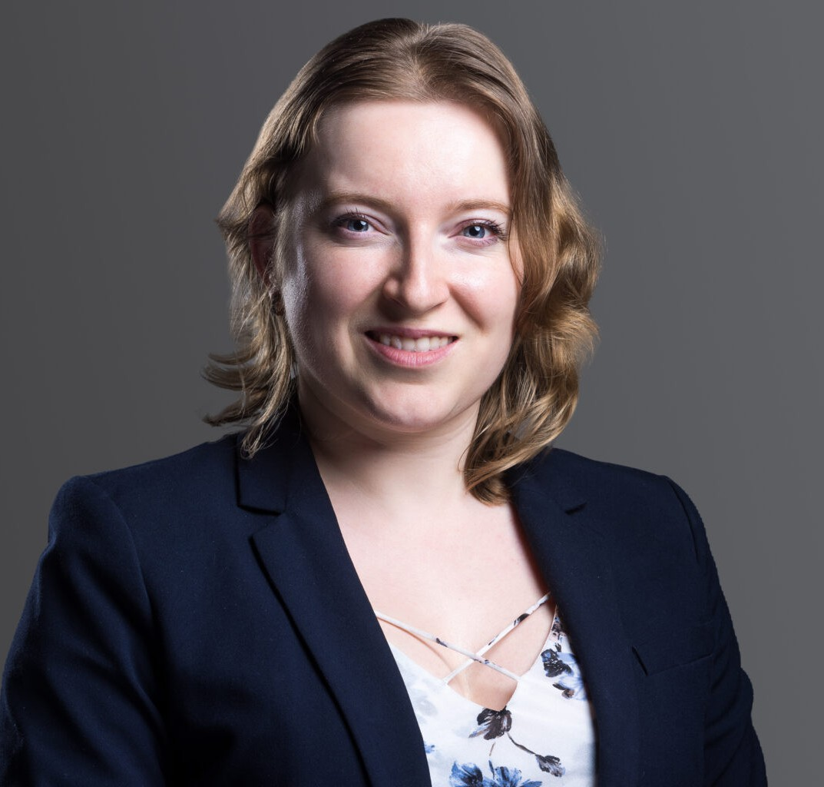

CHRISTINA SUAREZ

Associate

[Land Use](https://www.fennemorelaw.com/services/land-use/)

[Fresno](https://www.fennemorelaw.com/contact-us/fresno/)

P: 559.432.4500

F: 559.432.4500

[csuarez@fennemorelaw.com](mailto:csuarez@fennemorelaw.com)

“

I am not afraid – I was born to do this.

Joan of Arc

**CHRISTINA SUAREZ**

”

Christina Suarez is an associate in our Land Use practice group who works out of our Fresno Office. She is a knowledgeable researcher with a demonstrated history of working in the oil & energy industry with experience in petroleum matters, corporate social responsibility and petroleum geology.

Originally on the road to becoming an engineer, Christina was personally selected by a professor of Petroleum Engineering (who was also a patent attorney) to conduct research on climate

change, sustainability, corporate responsibility and ethics and negotiation – which led her to research centers in Germany and Belgium. Ultimately, Christina realized that her true passion was in the field of law, so she took her LSATs and the rest is history. In her practice, she’s most inspired by looking beyond just facts and figures, and working with people where she has the ability to solve their complex problems.

Outside of the office, you’ll find Christina in the ring where she practices martial arts (Black Belt in Karate) and spars with MMA fighters. When she really needs to unwind, she turns to classical

piano, drawing and all things related to science fiction.

# EDUCATION

J.D., U.C. Davis, School of Law

Recipient, Dean’s Merit Scholarship President, Christian Legal Society

Bluebook Editor, *Environs – Environmental Law Journal*

Phi Theta Kappa

M.S., Colorado School of Mines B.S., Colorado School of Mines

# AREAS OF PRACTICE

Land Use

Business & Finance Natural Resources Real Estate

# ARTICLES AND PRESENTATIONS

Author, “DWR Approves 15 Groundwater Sustainability Plans – Legal Implications,” California Water Law & Policy Reporter, April 1, 2025

Author, “Final Decision Regarding Long-Term Operation of the Central Valley Project and State Water Project,” California Water Law & Policy Reporter, February 1, 2025

Author, “Streamlining Conservation: The DEIS for the Desert Tortoise General Conservation Plan,” California Land Use Law & Policy Reporter, December 1, 2024

Author, “California Settles with Elk Grove Over City’s Violations of Affordable Housing Acts,” California Land Use Law & Policy Reporter, November 1, 2024

Author, “[Preparing for Change: Key Takeaways from California’s AB98](https://www.fennemorelaw.com/preparing-for-change-key-takeaways-from-californias-ab98/),” Fennemore Blog, October 17, 2024

Author, “Sonoma Superior Court Rings Bell on Sonoma County Groundwater Management,” California Water Law & Policy Reporter, October 1, 2024

Author, “Madera County to Take Steps to Curb Groundwater Use Through Participation in State Multibenefit Land Repurposing Program,” California Water Law & Policy Reporter, October 1, 2024

Author, “California to Develop Blueprint for Water Resilience in Response to Climate Change,” California Water Law & Policy Reporter, September 1, 2024

Author, “[Unraveling Chevron: A New Era in Agency Interpretation](https://www.fennemorelaw.com/a-new-era-in-agency-interpretation/),” Fennemore Blog, August 6, 2024

Author, “DWR’s Establishment of the State Water Project Long-Term Drought Plan,” California Water Law & Policy Reporter, August 1, 2024

Author, “EPA’s Designation of PFAS Under CERCLA,” California Water Law & Policy Reporter, June 1, 2024

Author, “California Updates Its Initial Water Allocation Forecast Based on Increased Rainfall,” California Water Law & Policy Reporter, March 1, 2024

Author, “California Sets its Initial Water Allocation Forecast in Time for the New Year,” California Water Law & Policy Reporter, January 1, 2024

Author, “California Senate Bill 659 Aims to Improve Groundwater Recharge Efforts,” California Water Law & Policy Reporter, December 1, 2023

Author, “California Department of Water Resources Releases Updated Determinations for Groundwater Sustainability Plans,” California Water Law & Policy Reporter, August 23, 2023

Author, “California Water Storage Investment Program Updates,” California Water Law & Policy Reporter, December 1, 2022

Author, “September 2022 Update of Central Valley Irrigated and Regulatory Program – Key Points for Growers and Other Stakeholders,” California Water Law & Policy Reporter, September 1, 2022

Author, “Government, the Oil Industry, and Climate Change” – SPE, *The Way Ahead*, 2018

Co-author, “Coal in Ruhr, Germany: Industry in Transition. An American Perspective” – *Society of Mining, Metallurgy and Exploration*, Mining Engineering, March 2019

# ADMISSIONS

California

# LANGUAGES

Spanish, Russian and English, Fluent