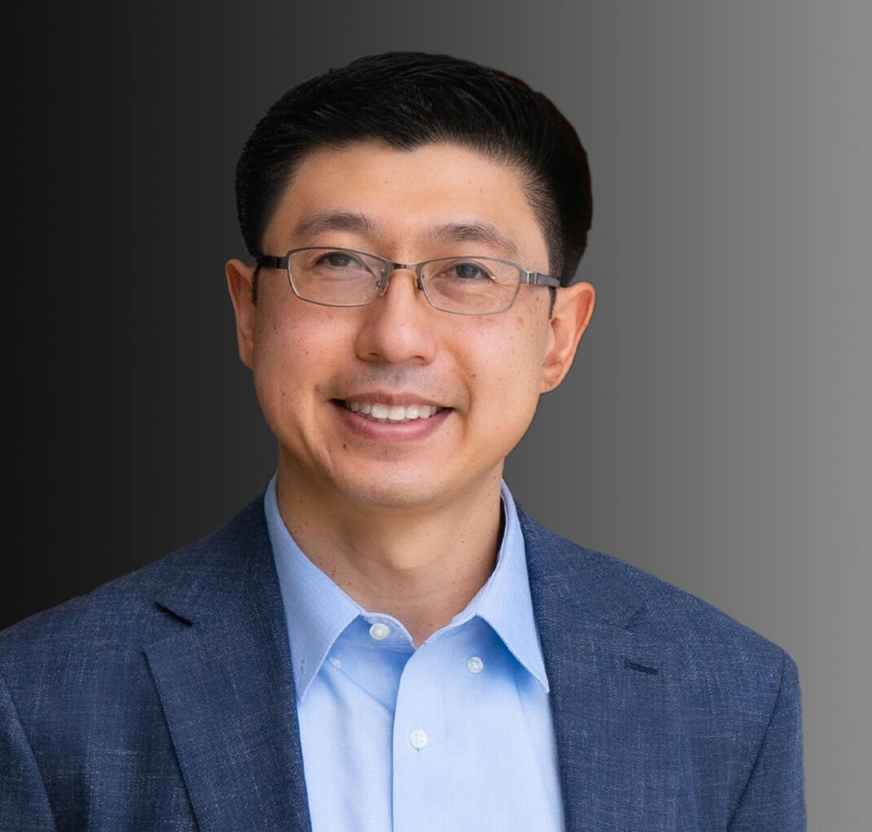

JAMES B. DE LOS REYES

Director

[Business Litigation](https://www.fennemorelaw.com/services/business-litigation/)

[Oakland](https://www.fennemorelaw.com/contact-us/oakland/)

P: 510.834.6600 F: 510.834.1928

[jdelosreyes@fennemorelaw.com](mailto:jdelosreyes@fennemorelaw.com)

# JAMES B. DE LOS REYES

James is a member of the firm’s [Construction](https://www.fennemorelaw.com/services/construction-law/) and [Business Litigation](https://www.fennemorelaw.com/services/business-litigation/) groups and focuses his practice on the representation of owners, builders, general contractors, and subcontractors in matters relating to construction, real estate, and general litigation. He represents his clients in all phases of litigation, from pre-litigation counseling and claims assessment to mediation,

arbitration, and/or trial.

While always prepared to litigate, James helps his clients navigate complex disputes with an eye towards efficient outcomes and completion of their respective projects, whether residential, commercial property, or public works. His practice includes contract negotiation, preparation, and risk management. James works alongside his clients to understand their needs, concerns and pain points and “helps things go right “so his clients can move on to their next big project or endeavor.

Before joining Fennemore, James represented clients in construction defect and general civil litigation matters with several Bay Area law firms.

James serves on the board of directors for Operation Dignity, a non-profit organization that provides housing and support services to the unhoused populations in the East Bay. He often serves as an alumni coach and guest judge for UC College of the Law Moot Court intercollegiate competition teams.

# EDUCATION

J.D., University of California College of the Law, San Francisco (formerly UC Hastings) B.A., Stanford University

# AREAS OF PRACTICE

Business Litigation Construction Law

# ARTICLES AND PRESENTATIONS

Featuring, “Attorney James de los Reyes on becoming a lawyer, diversity in the profession and community service,” San Francisco Business Times, May 23, 2023

Featuring, “Meet Our Donors!” Operation Dignity, May 2, 2023

# AWARDS AND HONORS

*Best Lawyers in America*®, Ones to Watch – Litigation – Construction, 2021-2025

*Best Lawyers in America*®, Ones to Watch – Construction Law, Personal Injury Litigation – Defendants, 2025

# PROFESSIONAL AND COMMUNITY ACTIVITIES

Member, Alameda County Bar Association

Member, Judiciary Committee, Filipino Bar Association of Northern California

# ADMISSIONS

California

U.S. District Court, Northern District of California