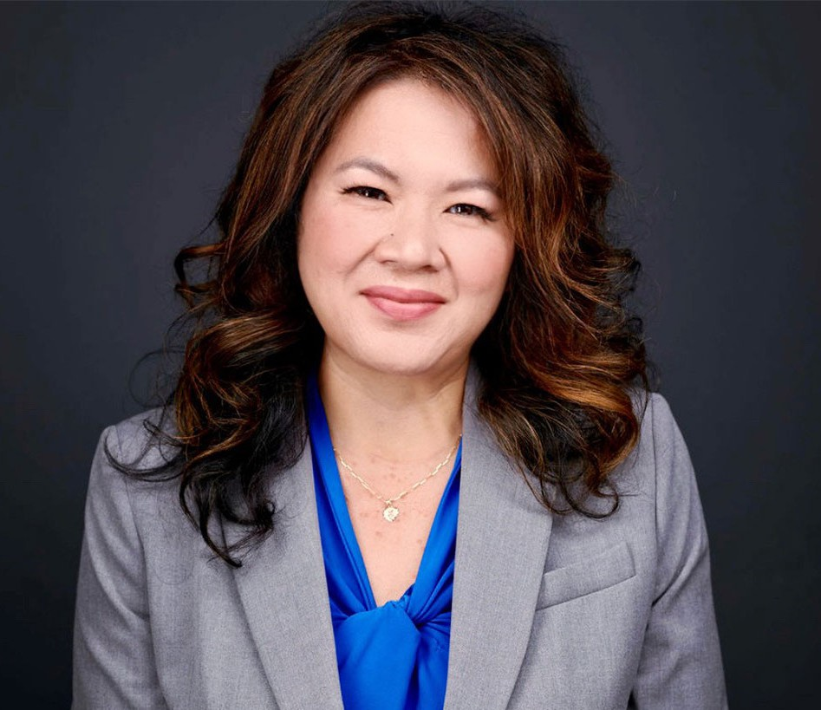

JUNE MONROE

Director

[Agribusiness](https://www.fennemorelaw.com/services/agribusiness/)

[Orange County](https://www.fennemorelaw.com/contact-us/orange-county/)

P: 949.430.3420 F: 949.752.0953

[jmonroe@fennemorelaw.com](mailto:jmonroe@fennemorelaw.com)

# JUNE MONROE

June Monroe is a director in our Irvine office who works in our Agribusiness and Employment Law Practice Groups. June climbed her way to the top by starting her legal career as a receptionist and then to a legal assistant. In 2008, she found herself a single mom of two young boys and wanting more for their future. While working fulltime and raising her family, June attended law

school. In 2012, she made the natural transition into an associate attorney and eventually partner.

June practices employment law, agricultural law, commercial law, secured transactions and general business law. She provides a wide range of services to agribusinesses – from startup formation to operating challenges. She concentrates on federal litigation, in district court and bankruptcy court, to enforce produce suppliers’ statutory rights under the Perishable Agricultural Commodities Act (PACA). She has recovered multi-million dollars in complex multi-party PACA

actions. June also assists agribusiness marketers in perfecting security interests in growing crops and related secured transactions under the adopted provisions of the Uniform Commercial Code and the Federal Food Security Act.

In addition to her agricultural law practice, June also advises employers in employment and general business law matters. She has represented employers on wage and hour civil actions claims and wage and hour investigations and hearings before the U.S. Department of Labor and California Labor Commissioner. She has also successfully won unemployment insurance benefit appeals in multiple states. June has assisted numerous employers in developing employee

handbooks. She also regularly advises companies on everyday employment challenges from hiring practices, wage and hour issues, employment classification, sick time, protected leave

laws, layoffs, and termination practices – to best practices to avoid discrimination, harassment and retaliation claims.

June is the current Chair of the Agribusiness Committee, Business Law Section, of the California Lawyers Association for the State Bar of California.

Outside of work, June is a weekend painter and enjoys painting on canvas and murals. Her

newest passion (outside of the law) is painting fruits and vegetables for her agribusiness clients.

Agribusiness

Employment & Labor

Business Litigation

# EDUCATION

J.D., Concord Law School

B.A., California State University, Fullerton

# AREAS OF PRACTICE

Agribusiness

Employment & Labor Business Litigation

# PROFESSIONAL AND COMMUNITY ACTIVITIES

Member, State Bar of California

Member, Law Advisory Council, Concord Law School at Purdue University Global

Current Chair of the Agribusiness Committee; Business Law Section, California Lawyers Association

Past Vice-Chair of Programs of the Agribusiness Committee; Business Law Section, California Lawyers Association

Past Vice-Chair of Publications of the Agribusiness Committee; Business Law Section, California Lawyers Association

Member, Orange County Women Lawyers Association

# AWARDS AND HONORS

Recipient, Orange County Women Lawyers Association’s Diversity Bar Stipend Scholarship, May 2012

# ARTICLES AND PRESENTATIONS

Author, “[Finding Work-Life Balance as a Legal Professional](https://www.fennemorelaw.com/finding-work-life-balance-as-a-legal-professional/),” Fennemore Blog, December 11, 2024

Speaker, “Demystifying PACA: Navigating Compliance and Best Practices in the Produce Industry,” National Agricultural Law Center webinar, April 17, 2024

Speaker, “Playing By the Non-Compete Rules,” Western Growers Webinar, April 17, 2024.

Author, “[Webinar navigates Perishable Agricultural Commodities Act](https://www.hotsr.com/news/2024/apr/15/webinar-navigates-perishable-agricultural/),” The Sentinel-Record, April 15, 2024

Author, “[Ten Steps to Fight Freight Fraud](https://mailchi.mp/fennemorelaw/fennmore-general-elections-federal-and-state-update-dont-let-it-surprise-you-15828874?e=92ddb0f1de),” Fennemore Client Alert, April 5, 2024

Author, “[Thursday Thoughts with June Monroe: Employment Changes Taking Effect in the](https://www.fennemorelaw.com/thursday-thoughts-with-june-monroe-employment-changes-taking-effect-in-the-agribusiness-industry-in-2024/) [Agribusiness Industry in 2024](https://www.fennemorelaw.com/thursday-thoughts-with-june-monroe-employment-changes-taking-effect-in-the-agribusiness-industry-in-2024/),” Fennemore Blog, March 21, 2024

Interview, “[PACA LAW with June Monroe of Fennemore Law,](https://podcasters.spotify.com/pod/show/theproduceindustrypodcast/episodes/PACA-Law-w-June-Monroe-of-Fennmore-Law---EP376-e2eeqte/a-aarife1)” The Produce Industry Podcast with Patrick Kelly, Episode 376, January 14, 2024

Featuring, “[CalBar 8.3 “Snitch Rule” – Required Misconduct Reporting Featuring](https://www.orangecountylawyers.com/news/california-bar-rule-8-3-misconduct/),” Orangecountylawyers.com, July 17, 2023

[Author, “It’s berry hard to believe, but growers and marketers may not be jointly liable for](https://mailchi.mp/ee2206c7ee9f/fennmore-general-elections-federal-and-state-update-dont-let-it-surprise-you-15828586?e=6383ff8993) [laborers’ wages, even in California,” Fennemore Client Alert, June 14, 2023](https://mailchi.mp/ee2206c7ee9f/fennmore-general-elections-federal-and-state-update-dont-let-it-surprise-you-15828586?e=6383ff8993)

Author, “It’s berry hard to believe, but growers and marketers may not be jointly liable for laborers’ wages, even in California,” California Lawyers Association, June 14, 2023

Speaker, “Veggie Wars” seminar, National Agricultural Law Center, Western Agricultural & Environmental Law Conference, May 4-5, 2023

Speaker, “Immigration Law for Agribusiness Employers” webinar, California Lawyers Association, Business Law Section, Agribusiness Committee, March 21, 2023

[Interview, “If you want it, go get it,” Fennemore Blog, December 8, 2022](https://bit.ly/3uyPTqI)

Featuring, “OCWLA Featured Member, June Monroe,” Orange County Women Lawyers Association, November 14, 2022

“PACA Trust,” On-Demand Webinar for The Blue Book Services, Inc.’s New Hire Academy

# ADMISSIONS

California

U.S. District Court, Northern District of California

U.S. District Court, Eastern District of California

U.S. District Court, Central District of California

U.S. District Court, Southern District of California