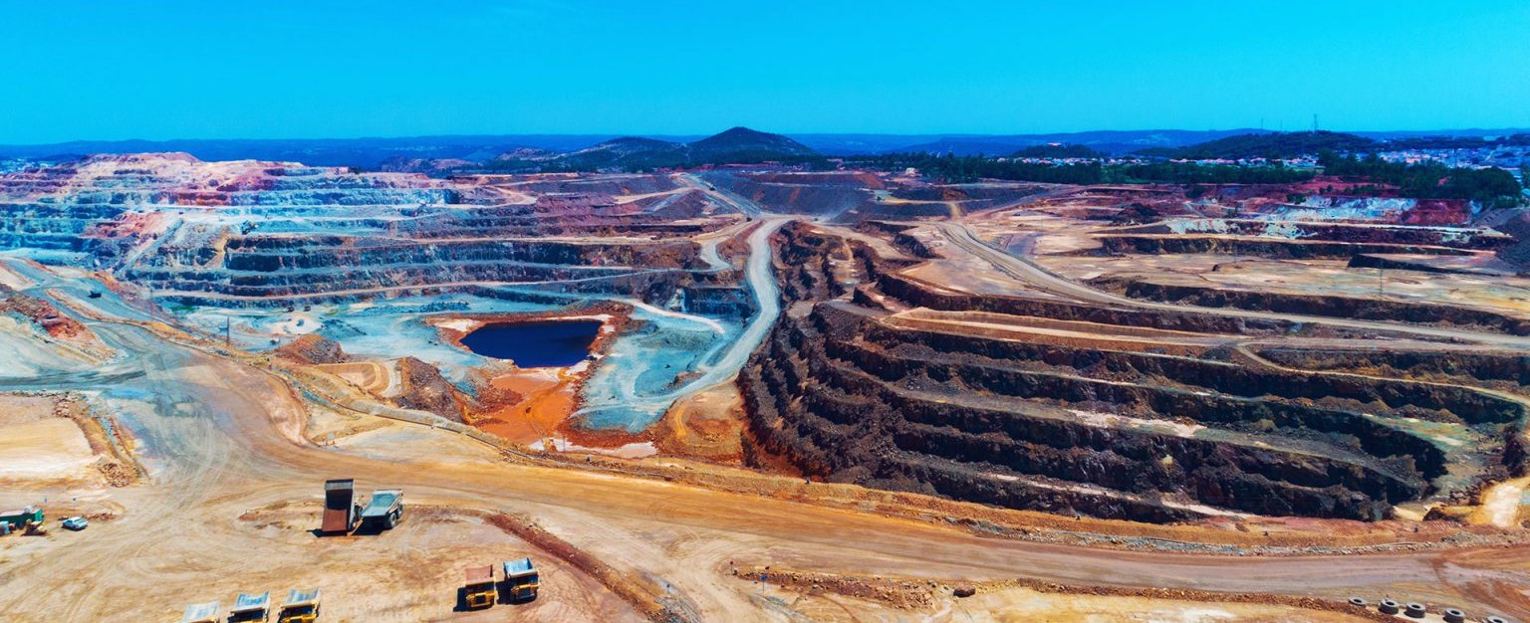

**Mining Law and Public Lands**

We have more than135 years of experience representing clients in minerals development.

**LEADERSHIP**

[MINING LAW](https://www.fennemorelaw.com/services/mining-law-and-public-lands/)

[BUSINESS &](https://www.fennemorelaw.com/services/business-and-finance/) [FINANCE](https://www.fennemorelaw.com/services/business-and-finance/)

[**Sarah A. Strunk**](https://www.fennemorelaw.com/people/attorneys/sarah-a-strunk/)

Director

[**San Diego**](https://www.fennemorelaw.com/contact-us/#san-diego)

PH 602.916.5327

FX 619.231.4372

[sstrunk@fennemorela](mailto:sstrunk@fennemorelaw.com) [w.com](mailto:sstrunk@fennemorelaw.com)

WHAT WE DO

We have more than 130 years of experience representing clients in mineral industry. This includes all facets of exploration, development and operation. Our mining law attorneys advise clients on due diligence, mineral title examinations, mining claim locations, maintenance and disputes. We can assist with drafting exploration agreements, including joint ventures and farm in/out

agreements; purchase and sale agreements of mining properties; contract operating and production agreements; marketing and tolling agreements of base and precious metals; as well as derivative transactions, including exchange-traded and off-exchange transactions as well as finance arrangements.

We have helped our clients permit exploration campaigns, greenfield mining projects and mine expansions on state and federal land. Then we help defend those permits in suits filed in state and federal court against the authorizing land or program management agencies.

Our work for clients encompasses projects related to mining laws and regulations throughout the United States, Mexico, Canada, South America, the Pacific Rim, the Republic of South Africa, and elsewhere around the world. Our mining lawyers work closely as a team, providing finance

law, tax, business entity advice, employment, [creditors’ rights law](https://www.fennemorelaw.com/services/practices/financial-restructuring-bankruptcy-creditors-rights), environmental, endangered species act work, water rights and public lands experience to a mining project.