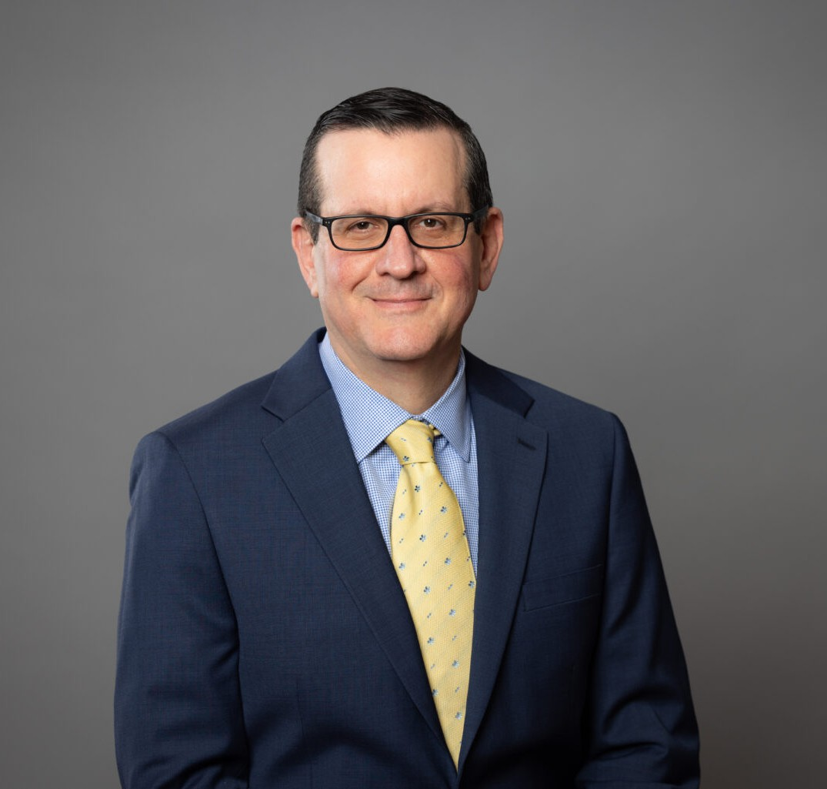

DANIEL A. ROBINSON

Director

[Natural Resources](https://www.fennemorelaw.com/services/natural-resources-energy-and-environmental/)

[Fennemore Forward](https://www.fennemorelaw.com/contact-us/fennemore-forward/)

P: 602.916.5392 F: 602.916.5999

[drobinson@fennemorelaw.com](mailto:drobinson@fennemorelaw.com)

# DANIEL A. ROBINSON

Daniel A. Robinson is a seasoned attorney who specializes in environmental law, commercial

law, alternative dispute resolution, and corporate risk management. Licensed in Pennsylvania, his extensive legal experience began in the insurance industry at AXA/XL and Ace/Chubb, and was honed in the corporate world at CrossAmerica Partners LP (NYSE:CAPL) and CST Brands, Inc. He most recently served as the Head of Litigation for Circle K Stores, Inc. (TSX:ACT.TO).

Daniel’s career is marked by his ability to blend legal comprehension and risk management, with strategic business counseling, making him a valuable asset to both individuals and businesses in need of guidance.

# EDUCATION

J.D., The Cleveland Marshall College of Law B.A., University of Vermont

# AREAS OF PRACTICE

Natural Resources Insurance Coverage

# ADMISSIONS

Pennsylvania

*DANIEL OPERATES REMOTELY, LICENSED IN PENNSYLVANIA, SERVING PHILADELPHIA. REACH OUT VIA EMAIL OR PHONE FOR VIRTUAL/IN-PERSON MEETINGS. FOR MAIL/DELIVERIES, USE THE OFFICE ADDRESS 1650 MARKET STREET, SUITE 3600, PMB #6849, PHILADELPHIA, PA 19103.