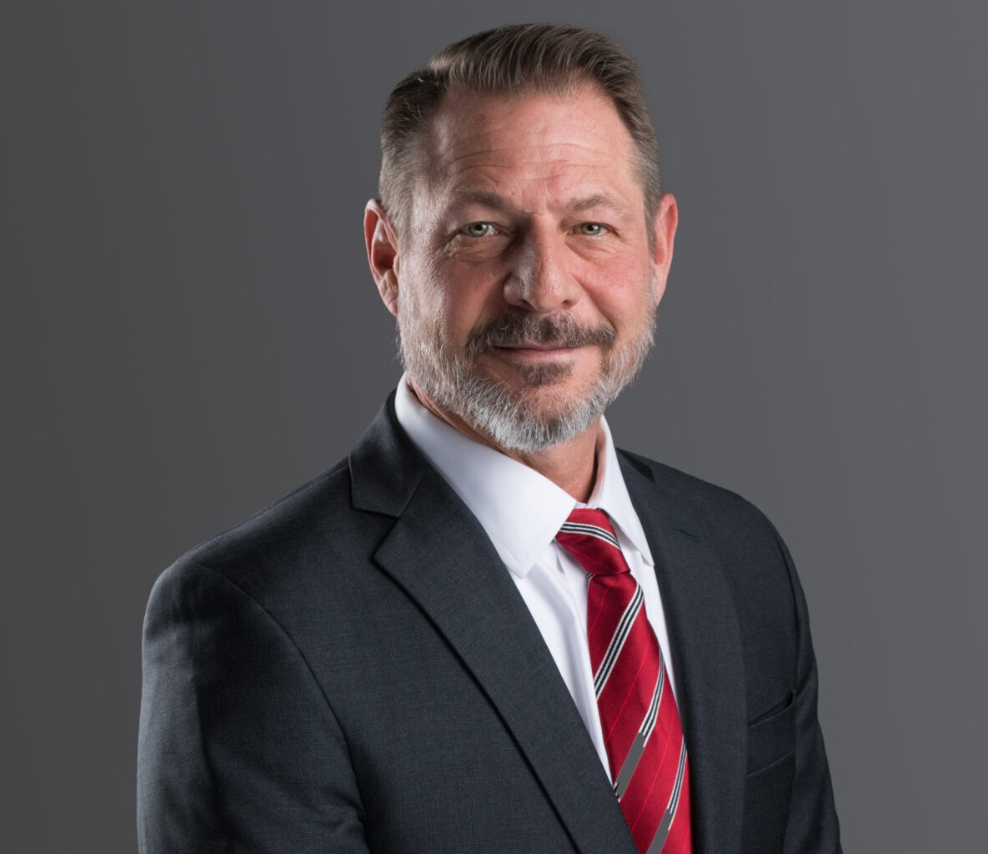

WILLIAM G. KLAIN

Director

[Business Litigation](https://www.fennemorelaw.com/services/business-litigation/)

[Phoenix](https://www.fennemorelaw.com/contact-us/phoenix/)

P: 602.916.5308

F: 602.916.5999

[wklain@fennemorelaw.com](mailto:wklain@fennemorelaw.com)

# WILLIAM G. KLAIN

With an impressive career spanning nearly 30 years, Bill Klain represents his clients in a broad range of business disputes and in the formation and governance of corporations, partnerships and limited liability companies. A distinguished figure in the fields of Arizona commercial litigation and corporate law, Bill helps his clients successfully navigate and resolve their disputes involving business divorces and dissolutions, fiduciary breaches, business torts, sales contracts, buy-sell agreements, non-compete, non-solicitation, and non-disclosure agreements, civil

appeals, and a variety of other complex civil legal matters. He is also an experienced private mediator and arbitrator, helping parties reach private resolutions of their civil matters,

Bill’s practice is defined by his dedication and commitment to his clients, impressive legal knowledge, and extensive courtroom and trial experience. His track record of success in commercial litigation has earned him a reputation as a formidable advocate for those

navigating the intricate landscape of business disputes. Bill’s deep understanding of corporate structures and governance enables his clients to establish and maintain their enterprises with

confidence.

Bill’s commitment to the legal profession is further exemplified by his active involvement in Arizona’s legal community. He serves as a member of the Arizona Judicial Council’s Committee on Superior Court and the State Bar of Arizona’s Civil Practice and Procedure Committee.

Previously, he chaired the Arizona Supreme Court’s Task Force on the Rules of Civil Procedure and served on the Court’s Advisory Committee on Rules of Evidence, Civil Justice Reform

Committee, and Business Court Advisory Committee, which developed Arizona’s Commercial Court. His involvement in these initiatives has provided Bill with a deep understanding of civil procedure and processes which he brings to bear for his clients in their matters.

With Bill Klain as your attorney, you gain a trusted legal partner who combines a wealth of experience with a tireless devotion to his clients. Whether you are facing complex litigation or require legal guidance in your business endeavors, Bill is an advocate and counselor you can depend on to protect your interests and guide you through every step of the legal process.

# EDUCATION

J.D., University of Denver

B.A., University of Richmond

# AREAS OF PRACTICE

**OTHER EXPERIENCE**

Business divorces and dissolutions Fiduciary breaches

Business torts Sales contracts

Buy-Sell agreements Civil appeals

Non-compete, non-solicitation, and non-disclosure agreements Various other commercial disputes

Receiverships Injunctions Trade Secrets

Failed commercial transactions Business Litigation

# AWARDS AND HONORS

Best Lawyers in America®, Lawyer of the Year, Bet-the-Company Litigation, 2025 Super Lawyers: “Top 50 Arizona,” 2018, 2022-24; Business Litigation, 2012-2024

The Best Lawyers in America®, Commercial Litigation, Bet-the-Company Litigation, 2015-2025 AV-Preeminent® Rating, Martindale-Hubbell®

“Top 100 Lawyers in Arizona for 2025,” AZ Business Magazine

“Top 100 Lawyers in Arizona for 2023” (Complex Corporate and Commercial Litigation), AZ Business Magazine

“Top Lawyer,” Phoenix Magazine, 2022, 2023

“Top 100 Lawyers in Arizona,” AZ Business Magazine, 2019

Chief Justice’s Outstanding Contribution to the Arizona Courts Award, 2016 State Bar of Arizona “Volunteer of the Month,” April 2016

Arizona’s Finest Lawyers (Sustaining Member), 2014-present State Bar of Arizona “Member of the Year,” 2013

Award of Excellence, Scottsdale Bar Association, 2012

State Bar of Arizona: President’s Award (Contributions to Civil Practice and Procedure), 2008

# ARTICLES AND PRESENTATIONS

Panelist, 2025 Civil Procedure Update, State Bar of Arizona, January 2025

Panelist, 2024 Civil Practice and Procedure Symposium, State Bar of Arizona, November 2024

Co-Author, “[Seven Significant Differences Between Arizona and Federal Civil Procedure in](https://www.fennemorelaw.com/seven-significant-differences-between-arizona-and-federal-civil-procedure-in-2024/) [2024](https://www.fennemorelaw.com/seven-significant-differences-between-arizona-and-federal-civil-procedure-in-2024/),” Fennemore Blog, June 20, 2024

“Meet the New Rules, (Not the) Same as the Old Rules ,” Arizona Attorney (State Bar of Arizona), December 2016

“Employee Misuse of Confidential Information,” December 2014

“A Long and Winding Road: How We Reached the 2014 Amendments,” Arizona Attorney (State Bar of Arizona), February 2014

“Fixing Holes Where the Rain Gets In: Seven Recent Arizona Civil Rule Amendments Dissected,” Record Reporter, February 2014

“Restrictive Covenants in Employment Agreements,” January 2014 “Customer List: Not Necessarily a Trade Secret,” November 2013

“Significant Differences Between Arizona and Federal Civil Procedure,” May 2013

“In a Lawsuit Arising from an Online Transaction, Where Should an Unhappy Buyer File Suit?”

September 2010

“Much Ado About Cullen: Twombly Not Arizona Law … for Now, ” Arizona Attorney (State Bar of Arizona), December 2009

“Asset Transfers and the Doctrine of Successor Liability,” August 2008

“Goodbye Peremptory Challenges: Underlying Rational, Experience to Date, and Strategic Considerations” (seminar co-chair and panelist), State Bar of Arizona “CLE by the Sea,” July 2023

“Sun Tzu and von Clausewitz in the Courtroom: Shaping the Battlefield through Dispositive Motions and Realizing that No Battle Plan Survives First Contact with the Enemy” (seminar cochair and panelist), State Bar of Arizona “CLE by the Sea,” July 2023

“’Toto, I’ve a Feeling We’re Not in Superior Court Anymore’: Contrasting State and Federal Trial Practice and How to Avoid Losing your Appeal Before it Starts” (seminar co-chair and panelist), State Bar of Arizona “CLE by the Sea,” July 2023

“Civil Practice Update” (panelist), State Bar of Arizona, January 2023

Judicial Conference Advisory Committee on Evidence Rules (panelist), Fall Meeting, 2022 Civil Practice and Procedure Symposium (panelist), State Bar of Arizona, September 2022

“Complex Civil Litigation and Tier 3 Cases in Commercial Court: Everything You’ve Always Needed to Know, But Were Afraid to Ask!” (panelist), Maricopa County Bar Association,

October 2021

“Where the Rubber Meets the Road: How the 2017 and 2018 Civil Rules Changes Are Impacting Litigation” (panelist), State Bar of Arizona, January 2019

“War Stories: Senior Litigators’ Tales from the Trenches and Lessons Learned” (co-presenter),

Maricopa County Bar Association Litigation and Real Estate Sections, December 2018

“2018 Civil Practice and Procedure Symposium” (seminar co-chair and panelist) State Bar of Arizona, April 2018

“Proportionality Takes Center Stage: The 2018 Revisions to the Arizona Rules of Civil Procedure” (co-presenter), Arizona Attorney General’s Office, Maricopa County Attorney’s Office, and

Sandra Day O’Connor Inn of Court, Spring 2018

“2018 Civil Justice Reforms: Case Management, ESI, and More” (panelist), State Bar of Arizona,

January 2018

“Meet the New Rules: The Restyled Arizona Rules of Civil Procedure” (seminar chair and panelist), State Bar of Arizona “CLE by the Sea,” July 2017

“Better, Faster, Cheaper: Case Management Reforms Coming to a Court Near You” (panelist),

State Bar of Arizona “CLE by the Sea,” July 2017

“The Changing Federal Rules: Proportionality and More” (seminar chair and panelist), State Bar of Arizona “CLE by the Sea,” July 2017

“Under New Management: Case Management Reform Rule Changes” (panelist), State Bar of Arizona Convention, June 2017

“Evidence Law Update” (panelist), State Bar of Arizona Convention, June 2015-2018

“2017 Civil Rules Changes: What Every Litigator Needs to Know” (co-presenter), Maricopa County Bar Association, February 2017

“A Time of Change: The 2017 ARCP Revisions” (panelist), Scottsdale Bar Association, February 2017

“2017 Civil Rules Update” (co-presenter), Arizona Attorney General’s Office, February 2017 “Evidence Law Update Reprise” (panelist), State Bar of Arizona, February 2017

“A Time of Change: The 2017 ARCP Revisions, and Proposals for 2018” (faculty member), State Bar of Arizona, January 2016

“Civil Law Updates” (faculty member), Arizona Judicial Conference, June 2016

“Where We’re Going, We Still Need Rules: Back to the Future in Civil Litigation” (panelist), State Bar of Arizona Convention, June 2016

“Sea Changes in the Federal and Arizona Rules of Civil procedure: The Winter 2016 Civil Rules Update” (panelist), State Bar of Arizona, February 2016

“2015 Amendments to the Arizona and Federal Rules of Civil Procedure,” Chair and Co-

Presenter, Arizona Attorney General’s Office, January 2016

“Civil Litigation Rules and Case Law Update” (panelist), State Bar of Arizona Convention, June 2015

“2015 Civil Practice and Procedure Symposium,” State Bar of Arizona, Seminar Chair and Panelist, April 2015

“The Rules They Are A-Changin’ (Again): 2015 Arizona Civil Rules Update,” State Bar of Arizona, Panelist, January 2015

# PROFESSIONAL AND COMMUNITY ACTIVITIES

American Bar Association

State Bar of Arizona: Civil Practice and Procedure Committee (Chair, 2011-2014; member, 2000-present); Ethical Rule 1.15 Task Force; Business Section

Committee on Superior Court, Arizona Judicial Council (State Bar of Arizona Representative) Coach, Veritas Preparatory Academy Mock Trial Team, 2020-2025

Adjunct Professor, Civil Pretrial Practice, Sandra Day O’Connor College of Law, Arizona State University, 2018-2022

Advisory Committee on Rules of Evidence, Arizona Supreme Court, 2012-2018 Committee on Civil Justice Reform, Arizona Supreme Court, 2017

Task Force on the Arizona Rules of Civil Procedure, Arizona Supreme Court: Co- Chair, 2014- 2016

Business Court Advisory Committee, Arizona Supreme Court, 2015 Commercial Court Review Committee, Arizona Supreme Court, 2018

Case Management and Trial Setting Task Force, Administrative Office of the Court, 2013 Commercial Court Practices and Procedure Committee, Maricopa County Superior Court Civil Study Committee, Maricopa County Superior Court

Committee on Civil Rules of Procedure for Limited Jurisdiction Courts, Arizona Supreme Court, 2011-2012

State Bar of Colorado

Past President, Scottsdale Bar Association Member, Maricopa County Bar Association Thurgood Marshall Inn of Court

# ADMISSIONS

Arizona Colorado

U.S. District Court, District of Arizona

U.S. Court of Appeals, Ninth Circuit